

**HUDSON FURNISHING**

**E-Project Documentation**

**Teacher Name : SIR AIJAZ AHMED**

**APTECH COMPUTER EDUCATION**

**HYDERABAD-1 PAKISTAN Issue Date : 5-Nov-2022**

# TABLE OF CONTENT

|  |  |  |
| --- | --- | --- |
| **S No** | **Contents** | **Page No** |
| 01 | Certificate | 3 |
| 02 | Acknowledgement | 4 |
| 03 | Project Report | 5 |
| 04 | Problem Definition | 6 |
| 05 | Customer Requirements  Specification (CRS) | 7 |
| 06 | Architecture Design of the Project | 9 |
| 07 | System Requirement | 10 |
| 08 | Task Sheet | 11 |
| 09 | Project Plan | 13 |
| 10 | Checklist of work Progress | 14 |
|  |  |  |
| 11 | Screen Shots | 15 |
| 12 | Source Code | 19 |

# CERTIFICATE

This is to certify that

**SYED M.HAMDAN**

Has successfully designed

HUDSON FURNISHING

Submitted by:

**SYED M.HAMDAN**

Date of Issue: 5-Nov-2022

**Authorized Signature:** Sir aijaz Ahmed

# ACKNOWLEDGEMENT

First and foremost, we would like to express our deep gratitude and most heartfelt thanks to almighty ALLAH for his blessings, for lightening up our heart with the torch of knowledge and for giving us the ability to complete this project.

We would like to thanks Aptech Worldwide and the team of EProject for their generous support and clarifying the doubts regarding e-project. We would like to acknowledge the way of explanation which the team of e-project gave in e-project to make website and we are equally grateful to our teacher (Sir Amjad Ali) for giving us a moral support and guiding us different matters regarding project in all the time about the research and writing of this project.

We are greatly indebted to Aptech Worldwide, Sir Amjad Ali, Faculty Members and ACE Hyderabad, Pakistan for encouragement and incessant help.

# PROJECT REPORT

**BY:**

**MUHAMMAD HAMDAN**

|  |  |  |  |
| --- | --- | --- | --- |
| **Project Title :** |  |  | **HUDSON FURNISHING,** |
| **Members Name :** |  |  | **SYED M.HAMDAN,ALLAH**  **BACHAYO,SYED UBAID**  **RAZA,HAMZA MEMON** |
| **Batch Code :** |  |  | **2206F** |
| **Start Date :** |  |  | **5-Nov-2022** |
| **End Date :** |  |  | **2-Dec-2022** |
| **Course :** |  |  | **ACCP (CPISM)** |
| **Teacher :** |  |  | **Sir AIJAZ Ali** |
| **Center Manager :** |  |  |  |
| **Center Academic Head :** | | | **Sir Shoaib Ahmed** |
| **Center Name :** | | | **ACE Hyderabad-1, Pakistan** |

Submitted as E Project Documentation

**PROBLEM DEFINITION**

**Hudson Furnishings is a furniture shop that specializes in all home furniture needs. We are a furniture shop, a bedroom furniture store, a sofa store, a mattress shop, and a kitchen furniture store, with an emphasis on interior design. We are the only Palliser custom order studio, which offers more than 300 different fabrics or leathers to meet all your furniture needs.**

**In our store we make it easy for you to shop for your personal style by providing you an easy way to navigate our showrooms where you will find everything you need to decorate & organize your home. Inside our space, you'll find designer furniture that's made with heartfelt passion, as well as immaculate attention to detail.**

**Our goal is to take off some of the stress that comes with overwhelming amount of furniture in the market to provide you with a pleasant shopping experience.**

**We intend to provide you with collections of ideas to décor your home to facilitate complimenting every piece of furniture you have in your home.**

**We’re here to help everyone, anywhere turn their house into a home.**

## Customer Requirement Specification

The portal will be designed as a Single-Page-Application and responsive Website with a set of pages and menus that represent choice of activities to be performed. The pages, menus, and other visual elements must be designed in a visually appealing manner with attractive fonts, colors, and animations.

All of these should also be laid out in a responsive manner

The Web site is to be created based on the following requirements.

1. The Top of the Page should be presented with a suitable logo and various images of furniture’s.
2. The site must contain various sections like BEDROOM, LIVING ROOM, DINING ROOM, HOME OFFICE, OUTDOOR etc. with various products listed into it.
3. A Menu should be provided with the section names and should be linked to the sections.
4. Clicking on any product should open pop-up window with images, description and price of the product.
5. Gallery should be added for viewing different images.
6. Feedback and Rating must be allowed to enter by the viewer
7. Site map, Gallery, about us, FAQ link, Contact us link must be added.
8. About Us and Contact Us: This menu option should display Email id, address, and contact number.
9. Section for various offers in the store should be provided with listing of offers with details.
10. Color combination must be uniform throughout the project.
11. Navigation must be smooth.

Over and above this, the portal should implement the following functionalities:

* Display a continuous scrolling ticker at the bottom of the page with current date, time, and location (hint: Use geolocation features of HTML5).
* Display a visitor count at the top right corner of the page beside a logo image.
* The menu options should change color on hover and also after clicking.
* Fade in and fade out options can be used for the menus.

PROJECT OBJECTIVE:

The Objective of this program is to give a sample project to work on real life projects. These applications help you build a larger more robust application.

The objective is not to teach you JavaScript/Dreamweaver but to provide you with a real life scenario and help you create basic applications using the tools.

You can revise the chapters before you start with the project.

This project is meant for students who have completed the module of

Dreamweaver. These programs should be done in the Lab sessions with assistance of the faculty if required.

It is very essential that a student has a clear understanding of the subject. Students

should go through the project and solve the assignments as per requirements given.

Kindly get back to eProjects Team in case of any doubts regarding the application or its objectives.

Architecture & Design of the Project:

Since the website will have client server architecture it will have one-tier architecture.

System Requirement:

|  |  |  |
| --- | --- | --- |
| **SR.No** | **Items** | **Description** |
| 01 | Operating System | Window XP, Win7 or win8 |
| 02 | Main Processor | Minimum 2ghz or better |
| 03 | Ram (Memory) | Minimum 512mb or better |
| 04 | Web Browser | Google Chrome or Firefox  (Latest) |
| 05 | Software | VISUAL STUDIO CODE, HTML editor, CS5.5 |

# TASK SHEET

|  |  |  |  |  |  |
| --- | --- | --- | --- | --- | --- |
| **Project Ref. No:** | | **Date of Preparation of Activity Plan:** | | |  |
| SR. No | Task | Actual  Start  Date: | Actual Day: | Team Mates  Names: | Stat us: |
| 01 | Planing | 10-Nov-2022 | 1 | SYED M.HAMDAN | YES |
| 02 | Data  Collection | 12-Nov-2022 | 1 | SYED  M.HAMDAN/ALLAH  BACHAYO/HAMZA/UBAI  D | YES |
| 03 | Designing  Home  Page | 13-Nov-2022 | 4 | SYED  M.HAMDAN/ALLAH  BACHAYO/HAMZA/UBAI  D | YES |
| 04 | Add sections | 17-Nov2022 | 9 | SYED  M.HAMDAN/ALLAH  BACHAYO/HAMZA/UBAI  D | YES |
| 05 | Check  Links | 19-Nov-2022 | 2 | SYED M.HAMDAN | YES |
| 06 | Finalizing | 20-Nov-2022 | 3 | SYED  M.HAMDAN/ALLAH  BACHAYO/HAMZA/UBAI  D | YES |
| 07 | Testing | 25-Nov-2022 | 2 | SYED M.HAMDAN | YES |
| 08 | Documentation | 25-Nov-2022 | 1 | SYED M.HAMDAN | YES |
| 09 | Uploading | 26-Nov-2022 | 2 | SYED M.HAMDAN | YES |

# PROJECT PLAN

* Website is able to execute quickly.
* The color scheme of the site looks attractive.
* The collection of data is authentic and taken by the most popular product websites.
* There is authentic information of facilities products with their specifications.
* Background is different to main page.
* The HOME is well prepared exactly for the same page as user clicks on the link..

● A visitor can also view the individual image of our every gallery.

# CHECK LIST OF WORK PROGRESS

|  |  |  |
| --- | --- | --- |
| **SR.No** | **Aspect Tested** | **Remarks** |
| 01 | Data Collection | **yes** |
| 02 | Designing Home Page | **yes** |
| 05 | Add sections | **yes** |
| 06 | Finalization | **Yes** |
| 08 | Tasting The Site | **Yes** |
| 09 | Documentation | **yes** |

# SCREEN SHOTS

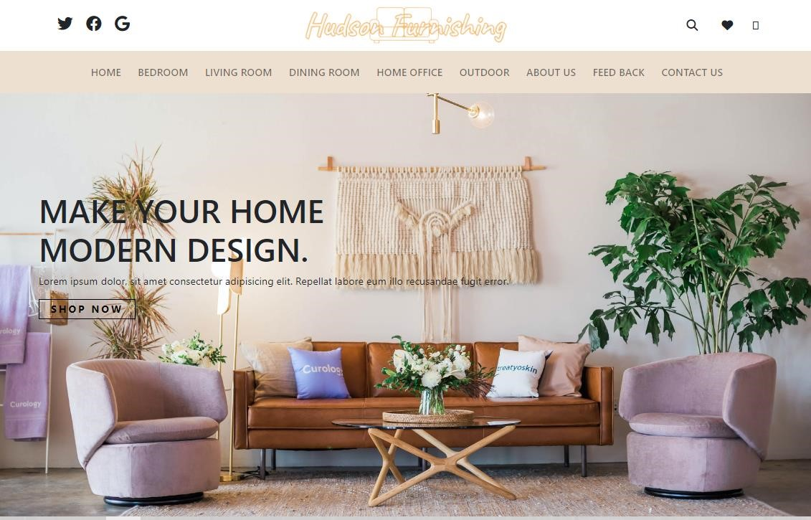

# Home-section-1

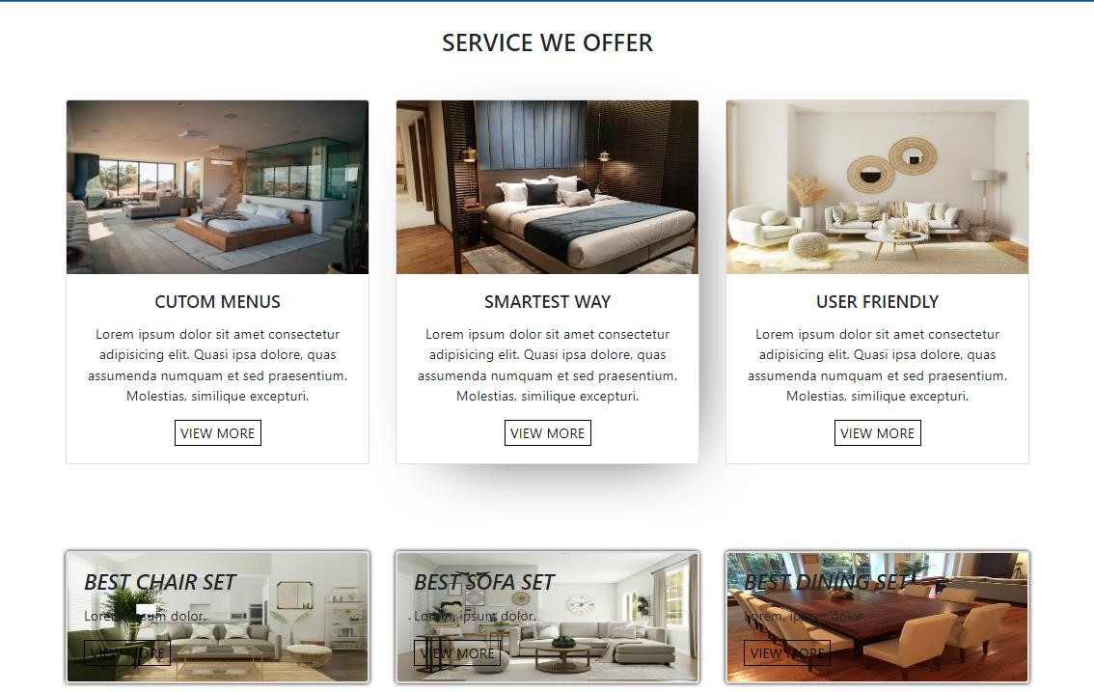

Section-2

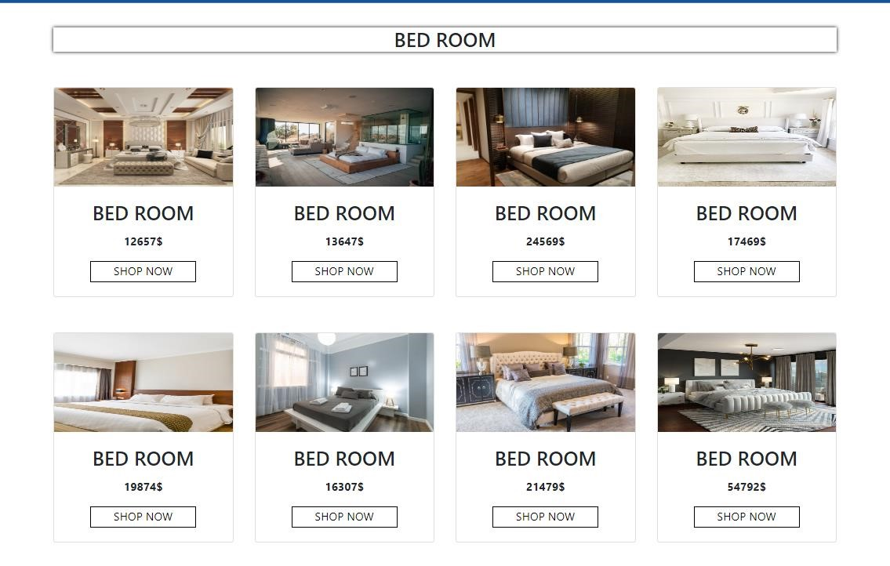

Section-3

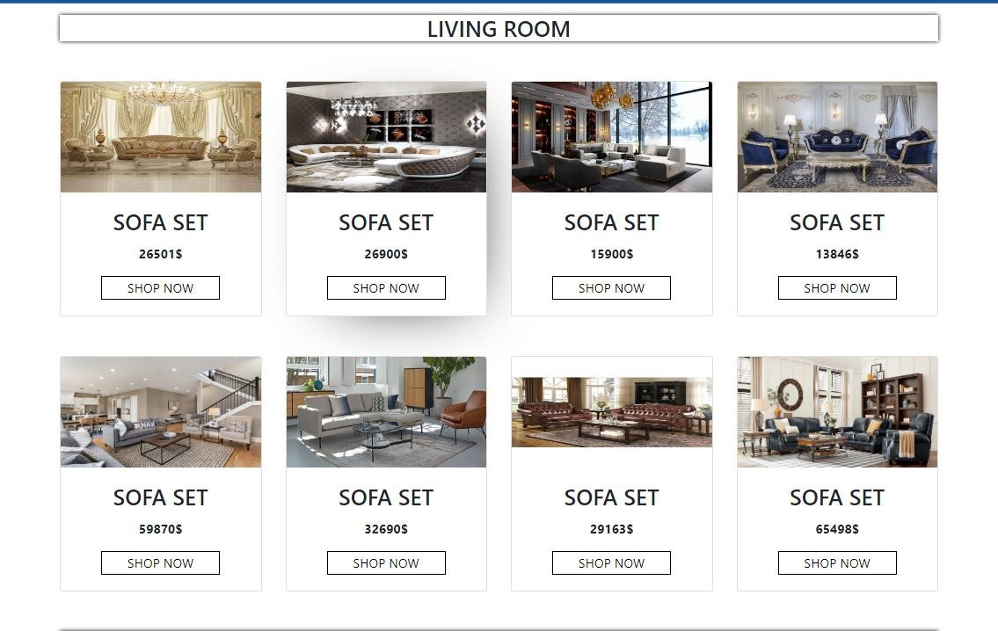

# Section-4

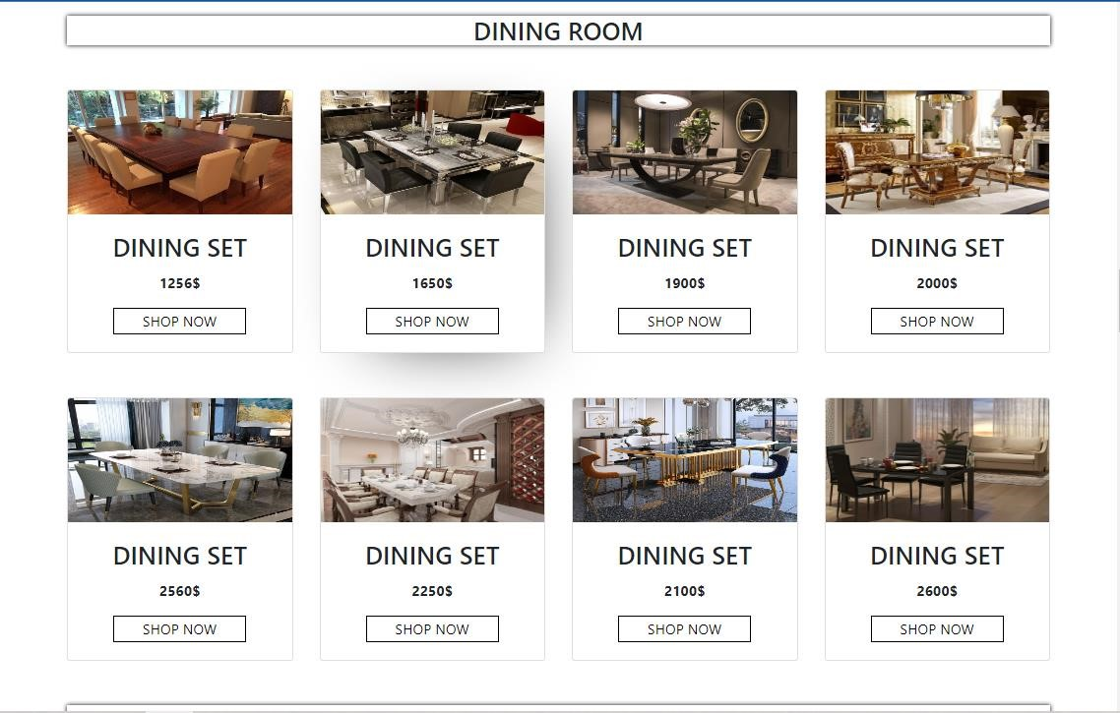

# Section-6

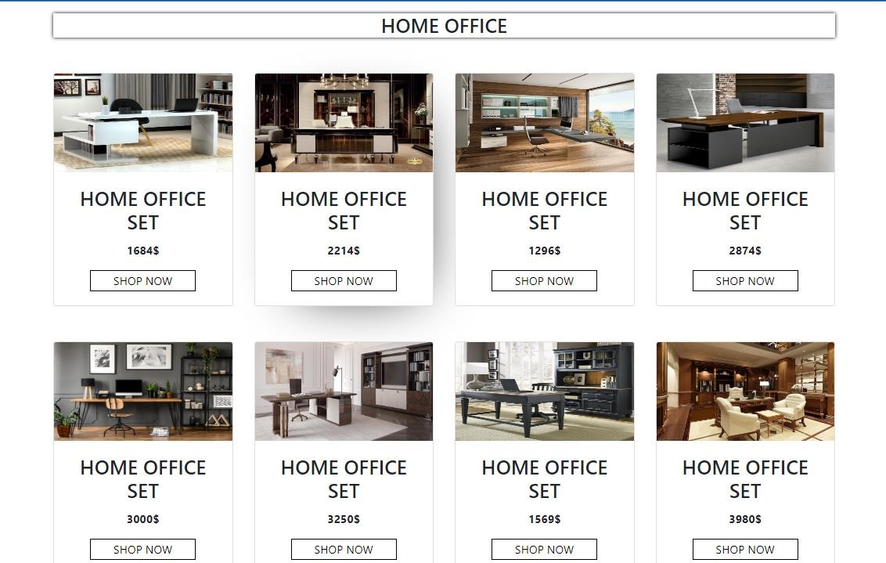

# Section-7

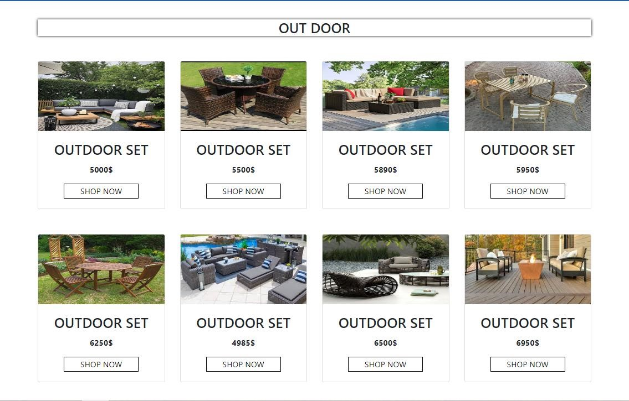

# Section-8-Gallery

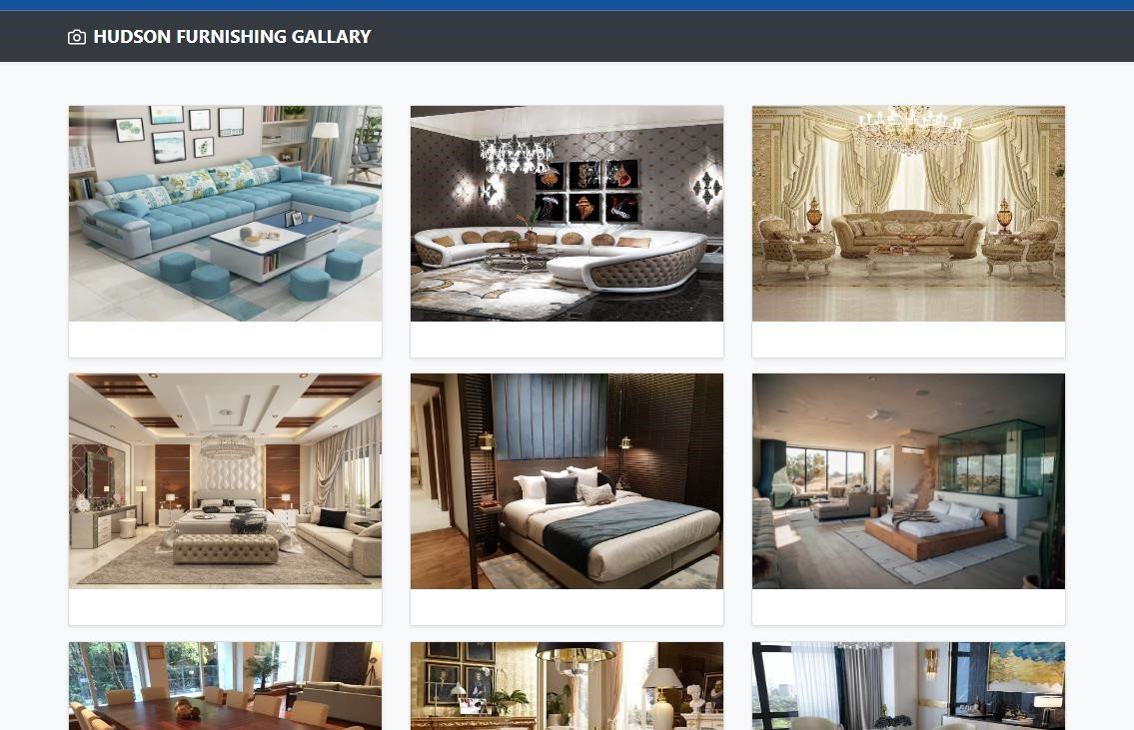

# FAQ and Sitemap

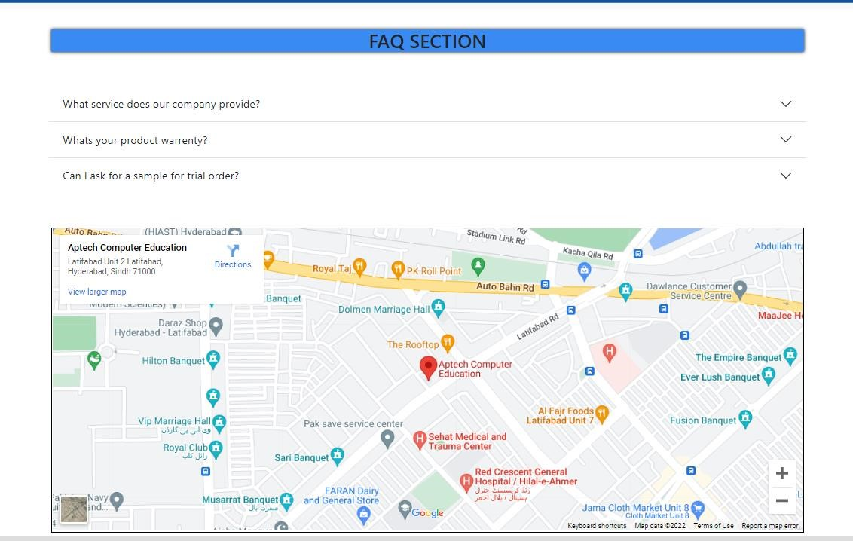

Feedback

-

form

About

-

us

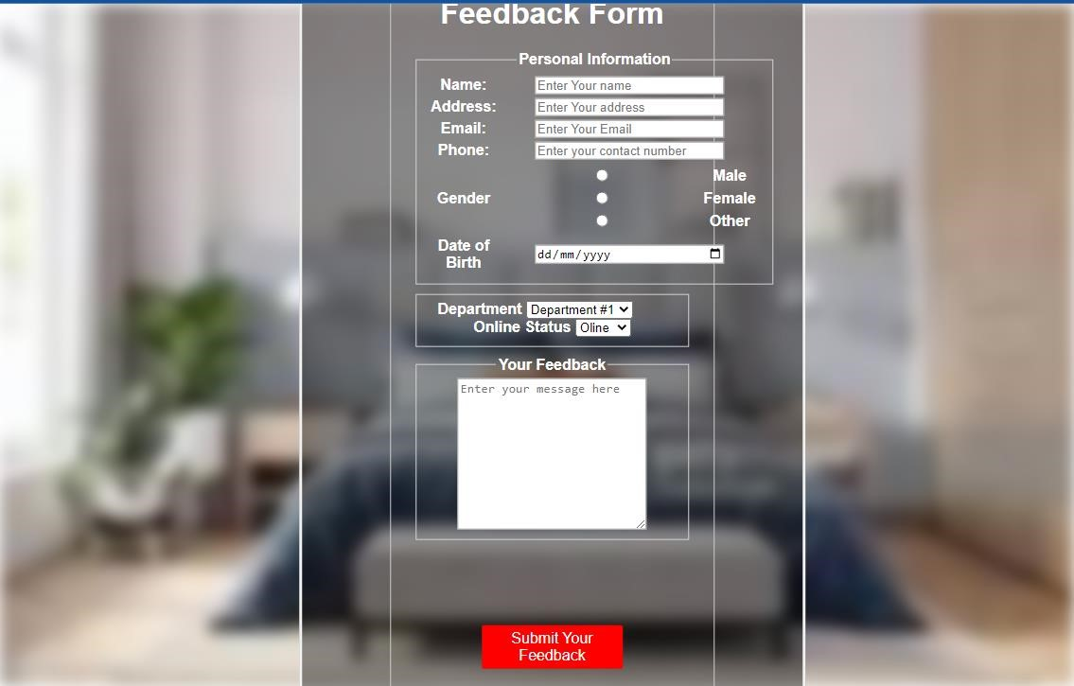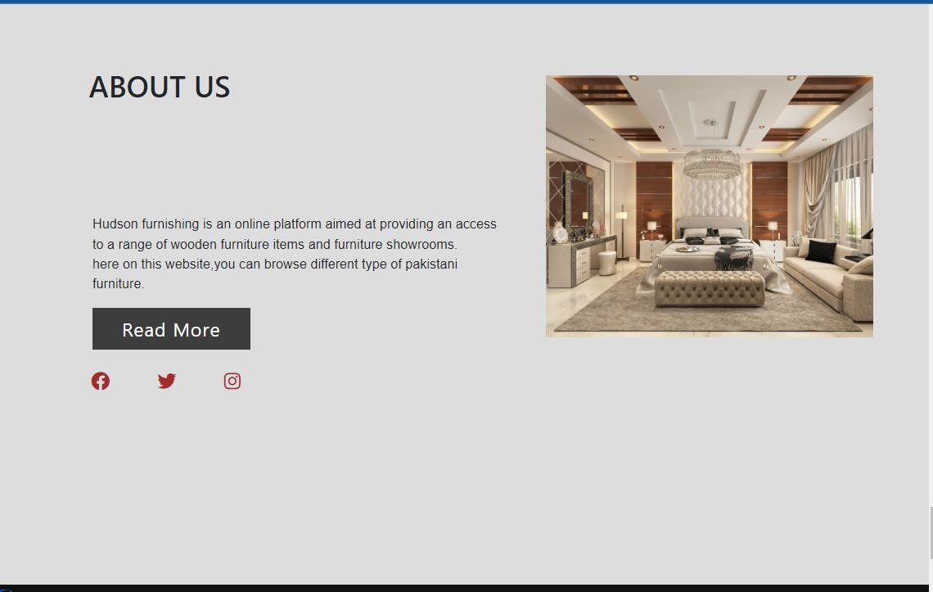

Product

-

pop up

FOOTER

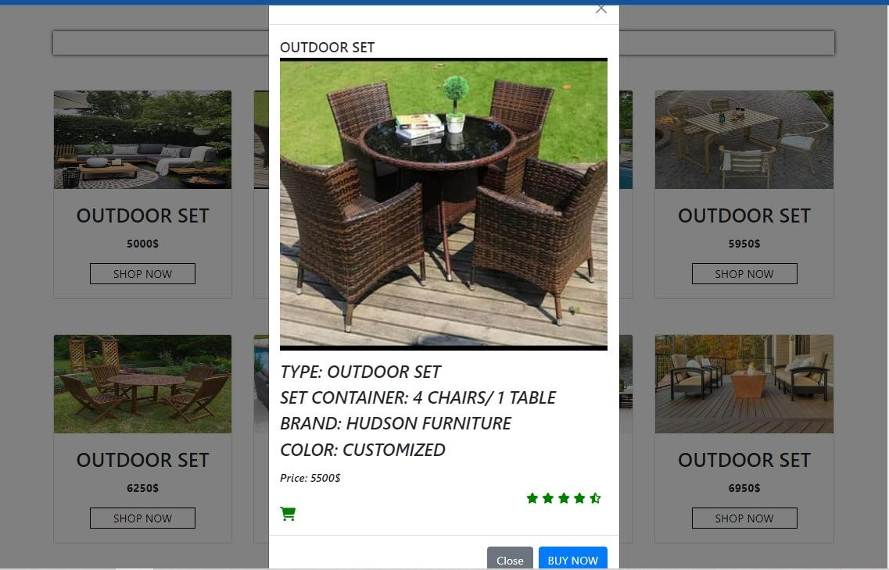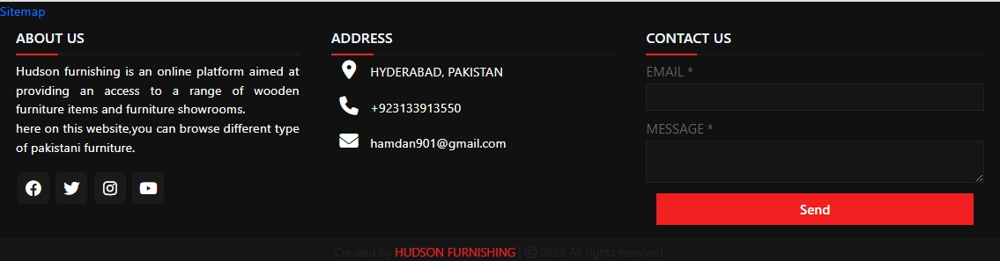

SOURCE CODE

<!doctype html>

<html lang="en">

<head>

<meta charset="utf-8">

<meta name="viewport" content="width=device-width, initial-scale=1">

<title>HUDSON FURNISHING</title>

<link rel="stylesheet" href="eproject.css">

<link href="https://cdn.jsdelivr.net/npm/bootstrap@5.2.2/dist/css/bootstrap.min.css" rel="stylesheet" integrity="sha384-

Zenh87qX5JnK2Jl0vWa8Ck2rdkQ2Bzep5IDxbcnCeuOxjzrPF/et3URy9Bv1WTRi" crossorigin="anonymous">

<script src="https://cdn.jsdelivr.net/npm/bootstrap@5.2.2/dist/js/bootstrap.bundle.min.js" integrity="sha384-OERcA2EqjJCMA+/3y+gxIOqMEjwtxJY7qPCqsdltbNJuaOe923+mo//f6V8Qbsw3" crossorigin="anonymous"></script>

<link rel="stylesheet"

href="https://cdn.jsdelivr.net/npm/bootstrap@4.6.1/dist/css/bootstrap.min.css">

<script src="https://cdn.jsdelivr.net/npm/jquery@3.6.0/dist/jquery.slim.min.js"></script>

<script src="https://cdn.jsdelivr.net/npm/popper.js@1.16.1/dist/umd/popper.min.js"></script>

<script src="https://cdn.jsdelivr.net/npm/bootstrap@4.6.1/dist/js/bootstrap.bundle.min.js"></script>

<link rel="stylesheet" href="https://cdnjs.cloudflare.com/ajax/libs/fontawesome/6.2.1/css/all.min.css">

</head>

<body>

<div class="container">

<div class="navbar-top">

<div class="social-link">

<i class="fa-brands fa-twitter" width="30px"></i>

<i class="fa-brands fa-facebook" width="30px"></i>

<i class="fa-brands fa-google" width="30px"></i>

</div>

<div class="logo">

<img src="logo-removebg-preview__3_-removebg-preview (1).png" alt="">

</div>

<div class="icons">

<i class="fa-solid fa-magnifying-glass" width="30px"></i>

<i class="fa-regular fa-heart" width="30px"></i>

<i class="fa-light fa-cart-shopping" width="30px"></i>

</div>

</div>

</div>

<div class="main-content">

<nav class="navbar navbar-expand-md" id="navbar-color">

<div class="container">

<!-- Toggler/collapsibe Button -->

<button class="navbar-toggler" type="button" data-toggle="collapse" datatarget="#collapsibleNavbar">

<span><i class="fa-solid fa-bars" width="30px"></i></span>

</button>

<!-- Navbar links -->

<div class="collapse navbar-collapse" id="collapsibleNavbar">

<ul class="navbar-nav">

<li class="nav-item">

<a class="nav-link" href="#">HOME</a>

</li>

<li class="nav-item">

<a class="nav-link" href="#bedroom">BEDROOM</a>

</li>

<li class="nav-item">

<a class="nav-link" href="#livingroom">LIVING ROOM</a>

</li>

<li class="nav-item">

<a class="nav-link" href="#diningroom">DINING ROOM</a>

</li>

<li class="nav-item">

<a class="nav-link" href="#homeoffice">HOME OFFICE</a>

</li>

<li class="nav-item">

<a class="nav-link" href="#outdoor">OUTDOOR</a>

</li>

<li class="nav-item">

<a class="nav-link" href="#aboutus">ABOUT US</a>

</li>

<li class="nav-item">

<a class="nav-link" href="New/feedback.htm">FEED BACK</a>

</li>

<li class="nav-item">

<a class="nav-link" href="#contactus">CONTACT US</a>

</li>

</ul>

</div>

</div>

</nav>

<div class="content">

<h1>

MAKE YOUR HOME <br>MODERN DESIGN.

</h1>

<p>Lorem ipsum dolor, sit amet consectetur adipisicing elit. Repellat labore eum illo recusandae fugit error.</p>

<div id="btn1"><button>SHOP NOW</button></div>

</div>

</div>

<div class="container">

<h3 class="text-center" style="padding-top:30px;">SERVICE WE OFFER</h3>

<div class="row" style="margin-top:50px;">

<div class="col-md-4 py-3 py-md-0">

<div class="card">

<img src="bedroom (2).jpg" alt="" class="card-img-top" height="200px">

<div class="card-body">

<h5 class="card-title text-center"> CUTOM MENUS</h5>

<P class="card-text text-center">Lorem ipsum dolor sit amet consectetur adipisicing elit.

Quasi ipsa dolore, quas assumenda numquam et sed praesentium. Molestias, similique excepturi.</P> <div id="btn2" class="text-center"><button>VIEW MORE</button></div>

</div>

</div>

</div>

<div class="col-md-4 py-3 py-md-0">

<div class="card">

<img src="bedroom (3).jpg" alt="" class="card-img-top" height="200px">

<div class="card-body">

<h5 class="card-title text-center">SMARTEST WAY</h5>

<P class="card-text text-center">Lorem ipsum dolor sit amet consectetur adipisicing elit.

Quasi ipsa dolore, quas assumenda numquam et sed praesentium. Molestias, similique excepturi.</P> <div id="btn2" class="text-center"><button>VIEW MORE</button></div>

</div>

</div>

</div>

<div class="col-md-4 py-3 py-md-0">

<div class="card">

<img src="spacejoy-c0JoR_-2x3E-unsplash.jpg" alt="" class="card-img-top" height="200px"> <div class="card-body">

<h5 class="card-title text-center">USER FRIENDLY</h5>

<P class="card-text text-center">Lorem ipsum dolor sit amet consectetur adipisicing elit.

Quasi ipsa dolore, quas assumenda numquam et sed praesentium. Molestias, similique excepturi.</P> <div id="btn2" class="text-center"><button>VIEW MORE</button></div>

</div>

</div>

</div>

</div>

</div>

<!-- card2 -->

<div class="container">

<div class="row" style="margin-top:100px;">

<div class="col-md-4 py-3 py-md-0">

<div class="card" id="tpc">

<img src="spacejoy-trG8989WjFA-unsplash.jpg" alt="" id="setimg" class="card image-top"> <div class="card-img-overlay">

<h4 class="card-title">

BEST CHAIR SET

</h4>

<p class="card-text"> Lorem, ipsum dolor.

</p>

<div id="btn2"><button>VIEW MORE</button></div>

</div>

</div>

</div>

<div class="col-md-4 py-3 py-md-0">

<div class="card" id="tpc">

<img src="spacejoy-RqO6kwm4tZY-unsplash.jpg" alt="" id="setimg" class="card image-top"> <div class="card-img-overlay">

<h4 class="card-title">

BEST SOFA SET

</h4>

<p class="card-text"> Lorem, ipsum dolor.

</p>

<div id="btn2"><button>VIEW MORE</button></div>

</div>

</div>

</div>

<div class="col-md-4 py-3 py-md-0">

<div class="card" id="tpc">

<img src="img25.jpg" alt="" id="setimg" class="card image-top">

<div class="card-img-overlay">

<h4 class="card-title">

BEST DINING SET

</h4>

<p class="card-text"> Lorem, ipsum dolor.

</p>

<div id="btn2"><button>VIEW MORE</button></div>

</div>

</div>

</div>

</div>

</div>

<!-- card2 -->

<!-- card3 bedroom -->

<div id="bedroom" class="container">

<h3 class="text-center" style="margin-top:50px; box-shadow: 0 0 5px black;">BED ROOM</h3>

<div class="row" style="margin-top:50px;">

<div class="col-md-3 py-3 py-md-0">

<div class="card" id="c">

<img src="img3.jpg" alt="" id="chrfst" class="card-img-top" height="140px"> <div class="card-body">

<h3 class="card-title text-center">

BED ROOM

</h3>

<P class="card-text text-center">12657$</P>

<div id="btn3" data-bs-toggle="modal" data-bs-target="#staticBackdrop1"><button>SHOP NOW</button></div>

</div>

</div>

</div>

<div class="col-md-3 py-3 py-md-0">

<div class="card" id="c">

<img src="bedroom (2).jpg" alt="" class="card-img-top" height="140px">

<div class="card-body">

<h3 class="card-title text-center">

BED ROOM

</h3>

<P class="card-text text-center">13647$</P>

<div id="btn3" data-bs-toggle="modal" data-bs-target="#staticBackdrop2"><button>SHOP NOW</button></div>

</div>

</div>

</div>

<div class="col-md-3 py-3 py-md-0">

<div class="card" id="c">

<img src="bedroom (3).jpg" alt="" class="card-img-top" height="140px">

<div class="card-body">

<h3 class="card-title text-center">

BED ROOM

</h3>

<P class="card-text text-center">24569$</P>

<div id="btn3" data-bs-toggle="modal" data-bs-target="#staticBackdrop3"><button>SHOP NOW</button></div>

</div>

</div>

</div>

<div class="col-md-3 py-3 py-md-0">

<div class="card" id="c">

<img src="bedroom (4).jpg" alt="" height="140px" class="card-img-top">

<div class="card-body">

<h3 class="card-title text-center">

BED ROOM

</h3>

<P class="card-text text-center">17469$</P>

<div id="btn3" data-bs-toggle="modal" data-bs-target="#staticBackdrop4"><button>SHOP NOW</button></div>

</div>

</div>

</div>

</div>

<div class="row" style="margin-top:50px;">

<div class="col-md-3 py-3 py-md-0">

<div class="card" id="c">

<img src="bedroom (5).jpg" alt="" height="140px" class="card-img-top">

<div class="card-body">

<h3 class="card-title text-center">

BED ROOM

</h3>

<P class="card-text text-center">19874$</P>

<div id="btn3" data-bs-toggle="modal" data-bs-target="#staticBackdrop5"><button>SHOP NOW</button></div>

</div>

</div>

</div>

<div class="col-md-3 py-3 py-md-0">

<div class="card" id="c">

<img src="bedroom (6).jpg" alt="" height="140px" class="card-img-top">

<div class="card-body">

<h3 class="card-title text-center">

BED ROOM

</h3>

<P class="card-text text-center">16307$</P>

<div id="btn3" data-bs-toggle="modal" data-bs-target="#staticBackdrop6"><button>SHOP NOW</button></div>

</div>

</div>

</div>

<div class="col-md-3 py-3 py-md-0">

<div class="card" id="c">

<img src="bedroom (7).jpg" alt="" height="140px" class="card-img-top">

<div class="card-body">

<h3 class="card-title text-center">

BED ROOM

</h3>

<P class="card-text text-center">21479$</P>

<div id="btn3" data-bs-toggle="modal" data-bs-target="#staticBackdrop7"><button>SHOP NOW</button></div>

</div>

</div>

</div>

<div class="col-md-3 py-3 py-md-0">

<div class="card" id="c">

<img src="bedroom.jpg" height="140px" alt="" class="card-img-top">

<div class="card-body">

<h3 class="card-title text-center">

BED ROOM

</h3>

<P class="card-text text-center">54792$</P>

<div id="btn3" data-bs-toggle="modal" data-bs-target="#staticBackdrop8"><button>SHOP NOW</button></div>

</div>

</div>

</div>

</div>

</div>

<!-- Button trigger bed room -->

<!-- Modal1 -->

<div class="modal fade" class="modal-dialog modal-dialog-centered modal-dialog-scrollable" id="staticBackdrop1" data-bs-backdrop="static" data-bs-keyboard="false" tabindex="-1" arialabelledby="staticBackdropLabel" aria-hidden="true">

<div class="modal-dialog">

<div class="modal-content">

<div class="modal-header">

<button type="button" class="btn-close" data-bs-dismiss="modal" arialabel="Close"></button>

3

</div>

<div class="modal-body">

<h1 class="modal-title fs-5" id="staticBackdropLabel last1">BED ROOM</h1> <img src="img3.jpg" alt="" width="100%" height="50%">

<p class="text2">

<h4>Type: bed room set</h4>

<h4>set container: double bed/ dressing table/ 2 drawers</h4>

<h4>Brand: Hudson furniture</h4>

<h4>color: customized</h4>

</p>

<h3 class="text">Price: 12657$</h3>

<i class="fa-solid fa-star" id="star" style="margin-left: 350px; color: green;"></i>

<i class="fa-solid fa-star" style="color:green;"></i>

<i class="fa-solid fa-star" style="color: green;"></i>

<i class="fa-solid fa-star" style="color: green;"></i>

<i class="fa-solid fa-star-half-stroke" style="color: green;"></i>

<i class="fa-solid fa-cart-shopping" style=" color:green; font-size: 20px;" onclick="myFunction()"></i>

</div>

<div class="modal-footer">

<button type="button" class="btn btn-secondary" data-bs-dismiss="modal">Close</button> <button type="button" class="btn btn-primary">BUY NOW</button>

</div>

</div>

</div>

</div>

<!-- Modal 1-->

<!-- Modal 2-->

<div class="modal fade" class="modal-dialog modal-dialog-centered modal-dialog-scrollable" id="staticBackdrop2" data-bs-backdrop="static" data-bs-keyboard="false" tabindex="-1" arialabelledby="staticBackdropLabel" aria-hidden="true">

<div class="modal-dialog">

<div class="modal-content">

<div class="modal-header">

<button type="button" class="btn-close" data-bs-dismiss="modal" arialabel="Close"></button>

</div>

<div class="modal-body">

<h1 class="modal-title fs-5" id="staticBackdropLabel last2">BED ROOM</h1> <img src="bedroom (2).jpg" alt="" width="100%" height="50%">

<p class="text2">

<h4>Type: bedroom set</h4>

<h4>set container: double bed/sofa</h4>

<h4>Brand: Hudson furniture</h4>

<h4>color: customized</h4>

</p>

<h3 class="text">Price: 13647$</h3>

<i class="fa-solid fa-star" id="star" style="margin-left: 350px; color: green;"></i>

<i class="fa-solid fa-star" style="color:green;"></i>

<i class="fa-solid fa-star" style="color: green;"></i>

<i class="fa-solid fa-star" style="color: green;"></i>

<i class="fa-solid fa-star-half-stroke" style="color: green;"></i>

<i class="fa-solid fa-cart-shopping" style=" color:green; font-size: 20px;" onclick="myFunction()"></i>

</div>

<div class="modal-footer">

<button type="button" class="btn btn-secondary" data-bs-dismiss="modal">Close</button> <button type="button" class="btn btn-primary">BUY NOW</button>

</div>

</div>

</div>

</div>

<!-- Modal 2-->

<!-- Modal 3-->

<div class="modal fade" class="modal-dialog modal-dialog-centered modal-dialog-scrollable" id="staticBackdrop3" data-bs-backdrop="static" data-bs-keyboard="false" tabindex="-1" arialabelledby="staticBackdropLabel" aria-hidden="true">

<div class="modal-dialog">

<div class="modal-content">

<div class="modal-header">

<button type="button" class="btn-close" data-bs-dismiss="modal" arialabel="Close"></button>

</div>

<div class="modal-body">

<h1 class="modal-title fs-5" id="staticBackdropLabel last3">BED ROOM</h1> <img src="bedroom (3).jpg" alt="" width="100%" height="50%">

<p class="text2">

<h4>Type: bedroom set</h4>

<h4>set container: double bed</h4>

<h4>Brand: Hudson furniture</h4>

<h4>color: customized</h4>

</p>

<h3 class="text">Price: 24569$</h3>

<i class="fa-solid fa-star" id="star" style="margin-left: 350px; color: green;"></i>

<i class="fa-solid fa-star" style="color:green;"></i>

<i class="fa-solid fa-star" style="color: green;"></i>

<i class="fa-solid fa-star" style="color: green;"></i>

<i class="fa-solid fa-star-half-stroke" style="color: green;"></i>

<i class="fa-solid fa-cart-shopping" style=" color:green; font-size: 20px;" onclick="myFunction()"></i>

</div>

<div class="modal-footer">

<button type="button" class="btn btn-secondary" data-bs-dismiss="modal">Close</button> <button type="button" class="btn btn-primary">BUY NOW</button>

</div>

</div>

</div>

</div>

<!-- Modal 3-->

<!-- Modal 4-->

<div class="modal fade" class="modal-dialog modal-dialog-centered modal-dialog-scrollable" id="staticBackdrop4" data-bs-backdrop="static" data-bs-keyboard="false" tabindex="-1" arialabelledby="staticBackdropLabel" aria-hidden="true">

<div class="modal-dialog">

<div class="modal-content">

<div class="modal-header">

<button type="button" class="btn-close" data-bs-dismiss="modal" arialabel="Close"></button>

</div>

<div class="modal-body">

<h1 class="modal-title fs-5" id="staticBackdropLabel last4">BED ROOM</h1> <img src="bedroom (4).jpg" alt="" width="100%" height="50%">

<p class="text2">

<h4>Type: bedroom set</h4>

<h4>set container: double bed/drawer</h4>

<h4>Brand: Hudson furniture</h4>

<h4>color: customized</h4>

</p>

<h3 class="text">Price: 17469$</h3>

<i class="fa-solid fa-star" id="star" style="margin-left: 350px; color: green;"></i>

<i class="fa-solid fa-star" style="color:green;"></i>

<i class="fa-solid fa-star" style="color: green;"></i>

<i class="fa-solid fa-star" style="color: green;"></i>

<i class="fa-solid fa-star-half-stroke" style="color: green;"></i>

<i class="fa-solid fa-cart-shopping" style=" color:green; font-size: 20px;" onclick="myFunction()"></i>

</div>

<div class="modal-footer">

<button type="button" class="btn btn-secondary" data-bs-dismiss="modal">Close</button> <button type="button" class="btn btn-primary">BUY NOW</button>

</div>

</div>

</div>

</div>

<!-- Modal 4-->

<!-- Modal 5-->

<div class="modal fade" class="modal-dialog modal-dialog-centered modal-dialog-scrollable" id="staticBackdrop5" data-bs-backdrop="static" data-bs-keyboard="false" tabindex="-1" arialabelledby="staticBackdropLabel" aria-hidden="true">

<div class="modal-dialog">

<div class="modal-content">

<div class="modal-header">

<button type="button" class="btn-close" data-bs-dismiss="modal" arialabel="Close"></button>

</div>

<div class="modal-body">

<h1 class="modal-title fs-5" id="staticBackdropLabel last5">BED ROOM</h1> <img src="bedroom (5).jpg" alt="" width="100%" height="50%">

<p class="text2">

<h2>Type: bedroom set</h2>

<h2>set container: double bed</h2>

<h2>Brand: Hudson furniture</h2>

<h2>color: customized</h>

</p>

<h3 class="text">Price: 19874$</h3>

<i class="fa-solid fa-star" id="star" style="margin-left: 350px; color: green;"></i>

<i class="fa-solid fa-star" style="color:green;"></i>

<i class="fa-solid fa-star" style="color: green;"></i>

<i class="fa-solid fa-star" style="color: green;"></i>

<i class="fa-solid fa-star-half-stroke" style="color: green;"></i>

<i class="fa-solid fa-cart-shopping" style=" color:green; font-size: 20px;" onclick="myFunction()">

</i>

</div>

<div class="modal-footer">

<button type="button" class="btn btn-secondary" data-bs-dismiss="modal">Close</button> <button type="button" class="btn btn-primary">BUY NOW</button>

</div>

</div>

</div>

</div>

<!-- Modal 5-->

<!-- Modal 6-->

<div class="modal fade" class="modal-dialog modal-dialog-centered modal-dialog-scrollable" id="staticBackdrop6" data-bs-backdrop="static" data-bs-keyboard="false" tabindex="-1" arialabelledby="staticBackdropLabel" aria-hidden="true">

<div class="modal-dialog">

<div class="modal-content">

<div class="modal-header">

<button type="button" class="btn-close" data-bs-dismiss="modal" arialabel="Close"></button>

</div>

<div class="modal-body">

<h1 class="modal-title fs-5" id="staticBackdropLabel last6">BED ROOM</h1> <img src="bedroom (6).jpg" alt="" width="100%" height="50%">

<p class="text2">

<h4>Type: bedroom set</h4>

<h4>set container: double bed</h4>

<h4>Brand: Hudson furniture</h4>

<h4>color: customized</h4>

</p>

<h3 class="text">Price: 16307$</h3>

<i class="fa-solid fa-star" id="star" style="margin-left: 350px; color: green;"></i>

<i class="fa-solid fa-star" style="color:green;"></i>

<i class="fa-solid fa-star" style="color: green;"></i>

<i class="fa-solid fa-star" style="color: green;"></i>

<i class="fa-solid fa-star-half-stroke" style="color: green;"></i>

<i class="fa-solid fa-cart-shopping" style=" color:green; font-size: 20px;" onclick="myFunction()"></i>

</div>

<div class="modal-footer">

<button type="button" class="btn btn-secondary" data-bs-dismiss="modal">Close</button> <button type="button" class="btn btn-primary">BUY NOW</button>

</div>

</div>

</div>

</div>

<!-- Modal 6-->

<!-- Modal 7-->

<div class="modal fade" class="modal-dialog modal-dialog-centered modal-dialog-scrollable" id="staticBackdrop7" data-bs-backdrop="static" data-bs-keyboard="false" tabindex="-1" arialabelledby="staticBackdropLabel" aria-hidden="true">

<div class="modal-dialog">

<div class="modal-content">

<div class="modal-header">

<button type="button" class="btn-close" data-bs-dismiss="modal" arialabel="Close"></button>

</div>

<div class="modal-body">

<h1 class="modal-title fs-5" id="staticBackdropLabel last7">BED ROOM</h1> <img src="bedroom (7).jpg" alt="" width="100%" height="50%">

<p class="text2">

<h4>Type: bedroom set</h4>

<h4>set container: double bed/tables/drawer</h4>

<h4>Brand: Hudson furniture</h4>

<h4>color: customized</h4>

</p>

<h3 class="text">Price: 21479$</h3>

<i class="fa-solid fa-star" id="star" style="margin-left: 350px; color: green;"></i>

<i class="fa-solid fa-star" style="color:green;"></i>

<i class="fa-solid fa-star" style="color: green;"></i>

<i class="fa-solid fa-star" style="color: green;"></i>

<i class="fa-solid fa-star-half-stroke" style="color: green;"></i>

<i class="fa-solid fa-cart-shopping" style=" color:green; font-size: 20px;" onclick="myFunction()"></i>

</div>

<div class="modal-footer">

<button type="button" class="btn btn-secondary" data-bs-dismiss="modal">Close</button> <button type="button" class="btn btn-primary">BUY NOW</button>

</div>

</div>

</div>

</div>

<!-- Modal 7-->

<!-- Modal 8-->

<div class="modal fade" class="modal-dialog modal-dialog-centered modal-dialog-scrollable" id="staticBackdrop8" data-bs-backdrop="static" data-bs-keyboard="false" tabindex="-1" arialabelledby="staticBackdropLabel" aria-hidden="true">

<div class="modal-dialog">

<div class="modal-content">

<div class="modal-header">

<button type="button" class="btn-close" data-bs-dismiss="modal" arialabel="Close"></button>

</div>

<div class="modal-body">

<h1 class="modal-title fs-5" id="staticBackdropLabel last8">BED ROOM</h1> <img src="bedroom.jpg" alt="" width="100%" height="50%">

<p class="text2">

<h3>Type: bedroom set</h3>

<h3>set container: double bed/ 2 drawer/ 2 chair</h3>

<h3>Brand: Hudson furniture</h3>

<h3>color: customized</h3>

</p>

<h3 class="text">Price: 54792$</h3>

<i class="fa-solid fa-star" id="star" style="margin-left: 350px; color: green;"></i>

<i class="fa-solid fa-star" style="color:green;"></i>

<i class="fa-solid fa-star" style="color: green;"></i>

<i class="fa-solid fa-star" style="color: green;"></i>

<i class="fa-solid fa-star-half-stroke" style="color: green;"></i>

<i class="fa-solid fa-cart-shopping" style=" color:green; font-size: 20px;" onclick="myFunction()"></i>

</div>

<div class="modal-footer">

<button type="button" class="btn btn-secondary" data-bs-dismiss="modal">Close</button> <button type="button" class="btn btn-primary">BUY NOW</button>

</div>

</div>

</div>

</div>

<!-- Modal 8-->

<!-- card4 living room -->

<div id="livingroom" class="container">

<h3 class="text-center" style="margin-top:50px; box-shadow: 0 0 5px black;">LIVING ROOM</h3>

<div class="row" style="margin-top:50px;">

<div class="col-md-3 py-3 py-md-0">

<div class="card" id="c">

<img src="img16.jpg" alt="" height="140px" class="card-img-top">

<div class="card-body">

<h3 class="card-title text-center">

SOFA SET

</h3>

<P class="card-text text-center">26501$</P>

<div id="btn3" data-bs-toggle="modal" data-bs-target="#staticBackdrop9"><button>SHOP NOW</button></div>

</div>

</div>

</div>

<div class="col-md-3 py-3 py-md-0">

<div class="card" id="c">

<img src="img17.jpg" alt="" class="card-img-top" style="height:140px;">

<div class="card-body">

<h3 class="card-title text-center">

SOFA SET

</h3>

<P class="card-text text-center">26900$</P>

<div id="btn3" data-bs-toggle="modal" data-bs-

target="#staticBackdrop10"><button>SHOP NOW</button></div>

</div>

</div>

</div>

<div class="col-md-3 py-3 py-md-0">

<div class="card" id="c">

<img src="img18.jpg" alt="" class="card-img-top" style="height:140px;">

<div class="card-body">

<h3 class="card-title text-center">

SOFA SET

</h3>

<P class="card-text text-center">15900$</P>

<div id="btn3" data-bs-toggle="modal" data-bs-

target="#staticBackdrop11"><button>SHOP NOW</button></div>

</div>

</div>

</div>

<div class="col-md-3 py-3 py-md-0">

<div class="card" id="c">

<img src="img19.jpg" alt="" id="chrlst" height="140px" class="card-img-top">

<div class="card-body">

<h3 class="card-title text-center">

SOFA SET

</h3>

<P class="card-text text-center">13846$</P>

<div id="btn3" data-bs-toggle="modal" data-bs-

target="#staticBackdrop12"><button>SHOP NOW</button></div>

</div>

</div>

</div>

</div>

<div class="row" style="margin-top:50px;">

<div class="col-md-3 py-3 py-md-0">

<div class="card" id="c">

<img src="img20.jpg" alt="" height="140px" class="card-img-top">

<div class="card-body">

<h3 class="card-title text-center">

SOFA SET

</h3>

<P class="card-text text-center">59870$</P>

<div id="btn3" data-bs-toggle="modal" data-bs-

target="#staticBackdrop13"><button>SHOP NOW</button></div>

</div>

</div>

</div>

<div class="col-md-3 py-3 py-md-0 ">

<div class="card" id="c">

<img src="img21.jpg" alt="" height="140px" class="card-img-top">

<div class="card-body">

<h3 class="card-title text-center">

SOFA SET

</h3>

<P class="card-text text-center">32690$</P>

<div id="btn3" data-bs-toggle="modal" data-bs-

target="#staticBackdrop14"><button>SHOP NOW</button></div>

</div>

</div>

</div>

<div class="col-md-3 py-3 py-md-0">

<div class="card" id="c">

<img src="img22.jpg" alt="" height="140px" class="card-img-top">

<div class="card-body">

<h3 class="card-title text-center">

SOFA SET

</h3>

<P class="card-text text-center">29163$</P>

<div id="btn3" data-bs-toggle="modal" data-bs-

target="#staticBackdrop15"><button>SHOP NOW</button></div>

</div>

</div>

</div>

<div class="col-md-3 py-3 py-md-0">

<div class="card" id="c">

<img src="img23.jpg" alt="" height="140px" class="card-img-top">

<div class="card-body">

<h3 class="card-title text-center">

SOFA SET

</h3>

<P class="card-text text-center">65498$</P>

<div id="btn3" data-bs-toggle="modal" data-bs-

target="#staticBackdrop16"><button>SHOP NOW</button></div>

</div>

</div>

</div>

</div>

</div>

<!-- Button trigger living room -->

<!-- Modal1 -->

<div class="modal fade" class="modal-dialog modal-dialog-centered modal-dialog-scrollable" id="staticBackdrop9" data-bs-backdrop="static" data-bs-keyboard="false" tabindex="-1" arialabelledby="staticBackdropLabel" aria-hidden="true">

<div class="modal-dialog">

<div class="modal-content">

<div class="modal-header">

<button type="button" class="btn-close" data-bs-dismiss="modal" arialabel="Close"></button>

</div>

<div class="modal-body">

<h1 class="modal-title fs-5" id="staticBackdropLabel last1"> SOFA SET</h1> <img src="img16.jpg" alt="" width="100%" height="50%">

<p class="text2">

<h4>Type: Sofa set</h4>

<h4>set container: 3 sofa/ 1 table</h4>

<h4>Brand: Hudson furniture</h4>

<h4>color: customized</h4>

</p>

<h3 class="text">Price: 26501$</h3>

<i class="fa-solid fa-star" id="star" style="margin-left: 350px; color: green;"></i>

<i class="fa-solid fa-star" style="color:green;"></i>

<i class="fa-solid fa-star" style="color: green;"></i>

<i class="fa-solid fa-star" style="color: green;"></i>

<i class="fa-solid fa-star-half-stroke" style="color: green;"></i>

<i class="fa-solid fa-cart-shopping" style=" color:green; font-size: 20px;" onclick="myFunction()"></i>

</div>

<div class="modal-footer">

<button type="button" class="btn btn-secondary" data-bs-dismiss="modal">Close</button> <button type="button" class="btn btn-primary">BUY NOW</button>

</div>

</div>

</div>

</div>

<!-- Modal 1-->

<!-- Modal 2-->

<div class="modal fade" class="modal-dialog modal-dialog-centered modal-dialog-scrollable" id="staticBackdrop10" data-bs-backdrop="static" data-bs-keyboard="false" tabindex="-1" arialabelledby="staticBackdropLabel" aria-hidden="true">

<div class="modal-dialog">

<div class="modal-content">

<div class="modal-header">

<button type="button" class="btn-close" data-bs-dismiss="modal" arialabel="Close"></button>

</div>

<div class="modal-body">

<h1 class="modal-title fs-5" id="staticBackdropLabel last2">SOFA SET</h1> <img src="img17.jpg" alt="" width="100%" height="50%">

<p class="text2">

<h4>Type: Sofa set</h34>

<h4>set container: 1 sofa/ 1 table/ 2 drawer</h4>

<h4>Brand: Hudson furniture</h4>

<h4>color: customized</h4>

</p>

<h3 class="text">Price: 26900$</h3>

<i class="fa-solid fa-star" id="star" style="margin-left: 350px; color: green;"></i>

<i class="fa-solid fa-star" style="color:green;"></i>

<i class="fa-solid fa-star" style="color: green;"></i>

<i class="fa-solid fa-star" style="color: green;"></i>

<i class="fa-solid fa-star-half-stroke" style="color: green;"></i>

<i class="fa-solid fa-cart-shopping" style=" color:green; font-size: 20px;" onclick="myFunction()"></i>

</div>

<div class="modal-footer">

<button type="button" class="btn btn-secondary" data-bs-dismiss="modal">Close</button> <button type="button" class="btn btn-primary">BUY NOW</button>

</div>

</div>

</div>

</div>

<!-- Modal 2-->

<!-- Modal 3-->

<div class="modal fade" class="modal-dialog modal-dialog-centered modal-dialog-scrollable" id="staticBackdrop11" data-bs-backdrop="static" data-bs-keyboard="false" tabindex="-1" arialabelledby="staticBackdropLabel" aria-hidden="true">

<div class="modal-dialog">

<div class="modal-content">

<div class="modal-header">

<button type="button" class="btn-close" data-bs-dismiss="modal" arialabel="Close"></button>

</div>

<div class="modal-body">

<h1 class="modal-title fs-5" id="staticBackdropLabel last3">SOFA SET</h1> <img src="img18.jpg" alt="" width="100%" height="50%">

<p class="text2">

<h4>Type: Sofa set</h4>

<h4>set container: 4 sofa/ 1 table</h4>

<h4>Brand: Hudson furniture</h4>

<h4>color: customized</h4>

</p>

<h3 class="text">Price: 15900$</h3>

<i class="fa-solid fa-star" id="star" style="margin-left: 350px; color: green;"></i>

<i class="fa-solid fa-star" style="color:green;"></i>

<i class="fa-solid fa-star" style="color: green;"></i>

<i class="fa-solid fa-star" style="color: green;"></i>

<i class="fa-solid fa-star-half-stroke" style="color: green;"></i>

<i class="fa-solid fa-cart-shopping" style=" color:green; font-size: 20px;"

onclick="myFunction()"></i>

</div>

<div class="modal-footer">

<button type="button" class="btn btn-secondary" data-bs-dismiss="modal">Close</button> <button type="button" class="btn btn-primary">BUY NOW</button>

</div>

</div>

</div>

</div>

<!-- Modal 3-->

<!-- Modal 4-->

<div class="modal fade" class="modal-dialog modal-dialog-centered modal-dialog-scrollable" id="staticBackdrop12" data-bs-backdrop="static" data-bs-keyboard="false" tabindex="-1" arialabelledby="staticBackdropLabel" aria-hidden="true">

<div class="modal-dialog">

<div class="modal-content">

<div class="modal-header">

<button type="button" class="btn-close" data-bs-dismiss="modal" arialabel="Close"></button>

</div>

<div class="modal-body">

<h1 class="modal-title fs-5" id="staticBackdropLabel last4">SOFA SET</h1> <img src="img19.jpg" alt="" width="100%" height="50%">

<p class="text2">

<h4>Type: Sofa set</h4>

<h4>set container: 3 sofa/ 1 table/ 2 drawer</h4>

<h4>Brand: Hudson furniture</h4>

<h4>color: customized</h4>

</p>

<h3 class="text">Price: 13846$</h3>

<i class="fa-solid fa-star" id="star" style="margin-left: 350px; color: green;"></i>

<i class="fa-solid fa-star" style="color:green;"></i>

<i class="fa-solid fa-star" style="color: green;"></i>

<i class="fa-solid fa-star" style="color: green;"></i>

<i class="fa-solid fa-star-half-stroke" style="color: green;"></i>

<i class="fa-solid fa-cart-shopping" style=" color:green; font-size: 20px;" onclick="myFunction()"></i>

</div>

<div class="modal-footer">

<button type="button" class="btn btn-secondary" data-bs-dismiss="modal">Close</button> <button type="button" class="btn btn-primary">BUY NOW</button>

</div>

</div>

</div>

</div>

<!-- Modal 4-->

<!-- Modal 5-->

<div class="modal fade" class="modal-dialog modal-dialog-centered modal-dialog-scrollable" id="staticBackdrop13" data-bs-backdrop="static" data-bs-keyboard="false" tabindex="-1" arialabelledby="staticBackdropLabel" aria-hidden="true">

<div class="modal-dialog">

<div class="modal-content">

<div class="modal-header">

<button type="button" class="btn-close" data-bs-dismiss="modal" arialabel="Close"></button>

</div>

<div class="modal-body">

<h1 class="modal-title fs-5" id="staticBackdropLabel last5">SOFA SET</h1> <img src="img20.jpg" alt="" width="100%" height="50%">

<p class="text2">

<h4>Type: Sofa set</h4>

<h4>set container: 4 sofa/ 1 table/ 1 drawer</h4>

<h4>Brand: Hudson furniture</h4>

<h4>color: customized</h4>

</p>

<h3 class="text">Price: 59870$</h3>

<i class="fa-solid fa-star" id="star" style="margin-left: 350px; color: green;"></i>

<i class="fa-solid fa-star" style="color:green;"></i>

<i class="fa-solid fa-star" style="color: green;"></i>

<i class="fa-solid fa-star" style="color: green;"></i>

<i class="fa-solid fa-star-half-stroke" style="color: green;"></i>

<i class="fa-solid fa-cart-shopping" style=" color:green; font-size: 20px;" onclick="myFunction()"></i>

</div>

<div class="modal-footer">

<button type="button" class="btn btn-secondary" data-bs-dismiss="modal">Close</button> <button type="button" class="btn btn-primary">BUY NOW</button>

</div>

</div>

</div>

</div>

<!-- Modal 5-->

<!-- Modal 6-->

<div class="modal fade" class="modal-dialog modal-dialog-centered modal-dialog-scrollable" id="staticBackdrop14" data-bs-backdrop="static" data-bs-keyboard="false" tabindex="-1" arialabelledby="staticBackdropLabel" aria-hidden="true">

<div class="modal-dialog">

<div class="modal-content">

<div class="modal-header">

<button type="button" class="btn-close" data-bs-dismiss="modal" arialabel="Close"></button>

</div>

<div class="modal-body">

<h1 class="modal-title fs-5" id="staticBackdropLabel last6">SOFA SET</h1> <img src="img21.jpg" alt="" width="100%" height="50%">

<p class="text2">

<h4>Type: Sofa set</h4>

<h4>set container: 1 sofa/ 1 table/ 1 chair</h4>

<h4>Brand: Hudson furniture</h4>

<h4>color: customized</h4>

</p>

<h3 class="text">Price: 32690$</h3>

<i class="fa-solid fa-star" id="star" style="margin-left: 350px; color: green;"></i>

<i class="fa-solid fa-star" style="color:green;"></i>

<i class="fa-solid fa-star" style="color: green;"></i>

<i class="fa-solid fa-star" style="color: green;"></i>

<i class="fa-solid fa-star-half-stroke" style="color: green;"></i>

<i class="fa-solid fa-cart-shopping" style=" color:green; font-size: 20px;" onclick="myFunction()"></i>

</div>

<div class="modal-footer">

<button type="button" class="btn btn-secondary" data-bs-dismiss="modal">Close</button> <button type="button" class="btn btn-primary">BUY NOW</button>

</div>

</div>

</div>

</div>

<!-- Modal 6-->

<!-- Modal 7-->

<div class="modal fade" class="modal-dialog modal-dialog-centered modal-dialog-scrollable" id="staticBackdrop15" data-bs-backdrop="static" data-bs-keyboard="false" tabindex="-1" arialabelledby="staticBackdropLabel" aria-hidden="true">

<div class="modal-dialog">

<div class="modal-content">

<div class="modal-header">

<button type="button" class="btn-close" data-bs-dismiss="modal" arialabel="Close"></button>

</div>

<div class="modal-body">

<h1 class="modal-title fs-5" id="staticBackdropLabel last7">SOFA SET</h1>

<img src="img22.jpg" alt="" width="100%" height="50%">

<p class="text2">

<h4>Type: Sofa set</h4>

<h4>set container: 2 sofa/ 1 table/ 2 drawers</h4>

<h4>Brand: Hudson furniture</h4>

<h4>color: customized</h4>

</p>

<h3 class="text">Price: 29163$</h3>

<i class="fa-solid fa-star" id="star" style="margin-left: 350px; color: green;"></i>

<i class="fa-solid fa-star" style="color:green;"></i>

<i class="fa-solid fa-star" style="color: green;"></i>

<i class="fa-solid fa-star" style="color: green;"></i>

<i class="fa-solid fa-star-half-stroke" style="color: green;"></i>

<i class="fa-solid fa-cart-shopping" style=" color:green; font-size: 20px;" onclick="myFunction()"></i>

</div>

<div class="modal-footer">

<button type="button" class="btn btn-secondary" data-bs-dismiss="modal">Close</button> <button type="button" class="btn btn-primary">BUY NOW</button>

</div>

</div>

</div>

</div>

<!-- Modal 7-->

<!-- Modal 8-->

<div class="modal fade" class="modal-dialog modal-dialog-centered modal-dialog-scrollable" id="staticBackdrop16" data-bs-backdrop="static" data-bs-keyboard="false" tabindex="-1" arialabelledby="staticBackdropLabel" aria-hidden="true">

<div class="modal-dialog">

<div class="modal-content">

<div class="modal-header">

<button type="button" class="btn-close" data-bs-dismiss="modal" arialabel="Close"></button>

</div>

<div class="modal-body">

<h1 class="modal-title fs-5" id="staticBackdropLabel last8">SOFA SET</h1>

<img src="img23.jpg" alt="" width="100%" height="50%">

<p class="text2">

<h4>Type: Sofa set</h4>

<h4>set container: 3 sofa/ 1 table/ 2 drawers</h4>

<h4>Brand: Hudson furniture</h4>

<h4>color: customized</h4>

</p>

<h3 class="text">Price: 65498$</h3>

<i class="fa-solid fa-star" id="star" style="margin-left: 350px; color: green;"></i>

<i class="fa-solid fa-star" style="color:green;"></i>

<i class="fa-solid fa-star" style="color: green;"></i>

<i class="fa-solid fa-star" style="color: green;"></i>

<i class="fa-solid fa-star-half-stroke" style="color: green;"></i>

<i class="fa-solid fa-cart-shopping" style=" color:green; font-size: 20px;" onclick="myFunction()"></i>

</div>

<div class="modal-footer">

<button type="button" class="btn btn-secondary" data-bs-dismiss="modal">Close</button> <button type="button" class="btn btn-primary">BUY NOW</button>

</div>

</div>

</div>

</div>

<!-- Modal 8-->

<!-- card5 dining room -->

<div id="diningroom" class="container">

<h3 class="text-center" style="margin-top:50px; box-shadow: 0 0 5px black;">DINING ROOM</h3>

<div class="row" style="margin-top:50px;">

<div class="col-md-3 py-3 py-md-0">

<div class="card" id="c">

<img src="img25.jpg" alt="" height="140px" class="card-img-top">

<div class="card-body">

<h3 class="card-title text-center">

DINING SET

</h3>

<P class="card-text text-center">1256$</P>

<div id="btn3" data-bs-toggle="modal" data-bs-

target="#staticBackdrop17"><button>SHOP NOW</button></div>

</div>

</div>

</div>

<div class="col-md-3 py-3 py-md-0">

<div class="card" id="c">

<img src="img26.jpg" alt="" class="card-img-top" style="height:140px;">

<div class="card-body">

<h3 class="card-title text-center">

DINING SET

</h3>

<P class="card-text text-center">1650$</P>

<div id="btn3" data-bs-toggle="modal" data-bs-

target="#staticBackdrop18"><button>SHOP NOW</button></div>

</div>

</div>

</div>

<div class="col-md-3 py-3 py-md-0">

<div class="card" id="c">

<img src="img27.jpg" alt="" class="card-img-top" style="height:140px;">

<div class="card-body">

<h3 class="card-title text-center">

DINING SET

</h3>

<P class="card-text text-center">1900$</P>

<div id="btn3" data-bs-toggle="modal" data-bs-

target="#staticBackdrop19"><button>SHOP NOW</button></div>

</div>

</div>

</div>

<div class="col-md-3 py-3 py-md-0">

<div class="card" id="c">

<img src="img28.jpg" alt="" id="chrlst" height="140px" class="card-img-top">

<div class="card-body">

<h3 class="card-title text-center">

DINING SET

</h3>

<P class="card-text text-center">2000$</P>

<div id="btn3" data-bs-toggle="modal" data-bs-

target="#staticBackdrop20"><button>SHOP NOW</button></div>

</div>

</div>

</div>

</div>

<div class="row" style="margin-top:50px;">

<div class="col-md-3 py-3 py-md-0">

<div class="card" id="c">

<img src="img29.jpg" alt="" height="140px" class="card-img-top">

<div class="card-body">

<h3 class="card-title text-center">

DINING SET

</h3>

<P class="card-text text-center">2560$</P>

<div id="btn3" data-bs-toggle="modal" data-bs-

target="#staticBackdrop21"><button>SHOP NOW</button></div>

</div>

</div>

</div>

<div class="col-md-3 py-3 py-md-0">

<div class="card" id="c">

<img src="img30.jpg" alt="" height="140px" class="card-img-top">

<div class="card-body">

<h3 class="card-title text-center">

DINING SET

</h3>

<P class="card-text text-center">2250$</P>

<div id="btn3" data-bs-toggle="modal" data-bs-

target="#staticBackdrop22"><button>SHOP NOW</button></div>

</div>

</div>

</div>

<div class="col-md-3 py-3 py-md-0">

<div class="card" id="c">

<img src="img31.jpg" alt="" height="140px" class="card-img-top">

<div class="card-body">

<h3 class="card-title text-center">

DINING SET

</h3>

<P class="card-text text-center">2100$</P>

<div id="btn3" data-bs-toggle="modal" data-bs-

target="#staticBackdrop23"><button>SHOP NOW</button></div>

</div>

</div>

</div>

<div class="col-md-3 py-3 py-md-0">

<div class="card" id="c">

<img src="img24.jpg" alt="" height="140px" class="card-img-top">

<div class="card-body">

<h3 class="card-title text-center">

DINING SET

</h3>

<P class="card-text text-center">2600$</P>

<div id="btn3" data-bs-toggle="modal" data-bs-

target="#staticBackdrop24"><button>SHOP NOW</button></div>

</div>

</div>

</div>

</div>

</div>

<!-- Button trigger dining room -->

<!-- Modal1 -->

<div class="modal fade" class="modal-dialog modal-dialog-centered modal-dialog-scrollable" id="staticBackdrop17" data-bs-backdrop="static" data-bs-keyboard="false" tabindex="-1" arialabelledby="staticBackdropLabel" aria-hidden="true">

<div class="modal-dialog">

<div class="modal-content">

<div class="modal-header">

<button type="button" class="btn-close" data-bs-dismiss="modal" arialabel="Close"></button>

</div>

<div class="modal-body">

<h1 class="modal-title fs-5" id="staticBackdropLabel last1">DINING SET</h1> <img src="img25.jpg" alt="" width="100%" height="50%">

<p class="text2">

<h4>Type: dining set</h4>

<h4>set container: 12 chairs/ 1 table</h4>

<h4>Brand: Hudson furniture</h4>

<h4>color: customized</h4>

</p>

<h3 class="text">Price: 1256$</h3>

<i class="fa-solid fa-star" id="star" style="margin-left: 350px; color: green;"></i>

<i class="fa-solid fa-star" style="color:green;"></i>

<i class="fa-solid fa-star" style="color: green;"></i>

<i class="fa-solid fa-star" style="color: green;"></i>

<i class="fa-solid fa-star-half-stroke" style="color: green;"></i>

<i class="fa-solid fa-cart-shopping" style=" color:green; font-size: 20px;" onclick="myFunction()"></i>

</div>

<div class="modal-footer">

<button type="button" class="btn btn-secondary" data-bs-dismiss="modal">Close</button> <button type="button" class="btn btn-primary">BUY NOW</button>

</div>

</div>

</div>

</div>

<!-- Modal 1-->

<!-- Modal 2-->

<div class="modal fade" class="modal-dialog modal-dialog-centered modal-dialog-scrollable" id="staticBackdrop18" data-bs-backdrop="static" data-bs-keyboard="false" tabindex="-1" arialabelledby="staticBackdropLabel" aria-hidden="true">

<div class="modal-dialog">

<div class="modal-content">

<div class="modal-header">

<button type="button" class="btn-close" data-bs-dismiss="modal" arialabel="Close"></button>

</div>

<div class="modal-body">

<h1 class="modal-title fs-5" id="staticBackdropLabel last2">DINING SET</h1> <img src="img26.jpg" alt="" width="100%" height="50%">

<p class="text2">

<h4>Type: dining set</h4>

<h4>set container: 6 chairs/ 1 table</h4>

<h4>Brand: Hudson furniture</h4>

<h4>color: customized</h4>

</p>

<h3 class="text">Price: 1650$</h3>

<i class="fa-solid fa-star" id="star" style="margin-left: 350px; color: green;"></i>

<i class="fa-solid fa-star" style="color:green;"></i>

<i class="fa-solid fa-star" style="color: green;"></i>

<i class="fa-solid fa-star" style="color: green;"></i>

<i class="fa-solid fa-star-half-stroke" style="color: green;"></i>

<i class="fa-solid fa-cart-shopping" style=" color:green; font-size: 20px;" onclick="myFunction()"></i>

</div>

<div class="modal-footer">

<button type="button" class="btn btn-secondary" data-bs-dismiss="modal">Close</button> <button type="button" class="btn btn-primary">BUY NOW</button>

</div>

</div>

</div>

</div>

<!-- Modal 2-->

<!-- Modal 3-->

<div class="modal fade" class="modal-dialog modal-dialog-centered modal-dialog-scrollable" id="staticBackdrop19" data-bs-backdrop="static" data-bs-keyboard="false" tabindex="-1" arialabelledby="staticBackdropLabel" aria-hidden="true">

<div class="modal-dialog">

<div class="modal-content">

<div class="modal-header">

<button type="button" class="btn-close" data-bs-dismiss="modal" arialabel="Close"></button>

</div>

<div class="modal-body">

<h1 class="modal-title fs-5" id="staticBackdropLabel last3">DINING SET</h1> <img src="img27.jpg" alt="" width="100%" height="50%">

<p class="text2">

<h4>Type: dining set</h4>

<h4>set container: 5 chairs/ 1 table</h4>

<h4>Brand: Hudson furniture</h4>

<h4>color: customized</h4>

</p>

<h3 class="text">Price: 1900$</h3>

<i class="fa-solid fa-star" id="star" style="margin-left: 350px; color: green;"></i>

<i class="fa-solid fa-star" style="color:green;"></i>

<i class="fa-solid fa-star" style="color: green;"></i>

<i class="fa-solid fa-star" style="color: green;"></i>

<i class="fa-solid fa-star-half-stroke" style="color: green;"></i>

<i class="fa-solid fa-cart-shopping" style=" color:green; font-size: 20px;" onclick="myFunction()"></i>

</div>

<div class="modal-footer">

<button type="button" class="btn btn-secondary" data-bs-dismiss="modal">Close</button> <button type="button" class="btn btn-primary">BUY NOW</button>

</div>

</div>

</div>

</div>

<!-- Modal 3-->

<!-- Modal 4-->

<div class="modal fade" class="modal-dialog modal-dialog-centered modal-dialog-scrollable" id="staticBackdrop20" data-bs-backdrop="static" data-bs-keyboard="false" tabindex="-1" arialabelledby="staticBackdropLabel" aria-hidden="true">

<div class="modal-dialog">

<div class="modal-content">

<div class="modal-header">

<button type="button" class="btn-close" data-bs-dismiss="modal" arialabel="Close"></button>

</div>

<div class="modal-body">

<h1 class="modal-title fs-5" id="staticBackdropLabel last4">DINING SET</h1> <img src="img28.jpg" alt="" width="100%" height="50%">

<p class="text2">

<h4>Type: dining set</h4>

<h4>set container: 4 chairs/ 1 table</h4>

<h4>Brand: Hudson furniture</h4>

<h4>color: customized</h4>

</p>

<h3 class="text">Price: 2000$</h3>

<i class="fa-solid fa-star" id="star" style="margin-left: 350px; color: green;"></i>

<i class="fa-solid fa-star" style="color:green;"></i>

<i class="fa-solid fa-star" style="color: green;"></i>

<i class="fa-solid fa-star" style="color: green;"></i>

<i class="fa-solid fa-star-half-stroke" style="color: green;"></i>

<i class="fa-solid fa-cart-shopping" style=" color:green; font-size: 20px;" onclick="myFunction()"></i>

</div>

<div class="modal-footer">

<button type="button" class="btn btn-secondary" data-bs-dismiss="modal">Close</button> <button type="button" class="btn btn-primary">BUY NOW</button>

</div>

</div>

</div>

</div>

<!-- Modal 4-->

<!-- Modal 5-->

<div class="modal fade" class="modal-dialog modal-dialog-centered modal-dialog-scrollable" id="staticBackdrop21" data-bs-backdrop="static" data-bs-keyboard="false" tabindex="-1" arialabelledby="staticBackdropLabel" aria-hidden="true">

<div class="modal-dialog">

<div class="modal-content">

<div class="modal-header">

<button type="button" class="btn-close" data-bs-dismiss="modal" arialabel="Close"></button>

</div>

<div class="modal-body">

<h1 class="modal-title fs-5" id="staticBackdropLabel last5">DINING SET</h1> <img src="img29.jpg" alt="" width="100%" height="50%">

<p class="text2">

<h4>Type: dining set</h4>

<h4>set container: 4 chairs/ 1 table</h4>

<h4>Brand: Hudson furniture</h4>

<h4>color: customized</h4>

</p>

<h3 class="text">Price: 2560$</h3>

<i class="fa-solid fa-star" id="star" style="margin-left: 350px; color: green;"></i>

<i class="fa-solid fa-star" style="color:green;"></i>

<i class="fa-solid fa-star" style="color: green;"></i>

<i class="fa-solid fa-star" style="color: green;"></i>

<i class="fa-solid fa-star-half-stroke" style="color: green;"></i>

<i class="fa-solid fa-cart-shopping" style=" color:green; font-size: 20px;" onclick="myFunction()"></i>

</div>

<div class="modal-footer">

<button type="button" class="btn btn-secondary" data-bs-dismiss="modal">Close</button> <button type="button" class="btn btn-primary">BUY NOW</button>

</div>

</div>

</div>

</div>

<!-- Modal 5-->

<!-- Modal 6-->

<div class="modal fade" class="modal-dialog modal-dialog-centered modal-dialog-scrollable" id="staticBackdrop22" data-bs-backdrop="static" data-bs-keyboard="false" tabindex="-1" arialabelledby="staticBackdropLabel" aria-hidden="true">

<div class="modal-dialog">

<div class="modal-content">

<div class="modal-header">

<button type="button" class="btn-close" data-bs-dismiss="modal" arialabel="Close"></button>

</div>

<div class="modal-body">

<h1 class="modal-title fs-5" id="staticBackdropLabel last6">DINING SET</h1> <img src="img30.jpg" alt="" width="100%" height="50%">

<p class="text2">

<h4>Type: dining set</h4>

<h4>set container: 8 chairs/ 1 table</h4>

<h4>Brand: Hudson furniture</h4>

<h4>color: customized</h4>

</p>

<h3 class="text">Price: 2250$</h3>

<i class="fa-solid fa-star" id="star" style="margin-left: 350px; color: green;"></i>

<i class="fa-solid fa-star" style="color:green;"></i>

<i class="fa-solid fa-star" style="color: green;"></i>

<i class="fa-solid fa-star" style="color: green;"></i>

<i class="fa-solid fa-star-half-stroke" style="color: green;"></i>

<i class="fa-solid fa-cart-shopping" style=" color:green; font-size: 20px;" onclick="myFunction()"></i>

</div>

<div class="modal-footer">

<button type="button" class="btn btn-secondary" data-bs-dismiss="modal">Close</button> <button type="button" class="btn btn-primary">BUY NOW</button>

</div>

</div>

</div>

</div>

<!-- Modal 6-->

<!-- Modal 7-->

<div class="modal fade" class="modal-dialog modal-dialog-centered modal-dialog-scrollable" id="staticBackdrop23" data-bs-backdrop="static" data-bs-keyboard="false" tabindex="-1" arialabelledby="staticBackdropLabel" aria-hidden="true">

<div class="modal-dialog">

<div class="modal-content">

<div class="modal-header">

<button type="button" class="btn-close" data-bs-dismiss="modal" arialabel="Close"></button>

</div>

<div class="modal-body">

<h1 class="modal-title fs-5" id="staticBackdropLabel last7">DINING SET</h1> <img src="img31.jpg" alt="" width="100%" height="50%">

<p class="text2">

<h4>Type: dining set</h4>

<h4>set container: 5 chairs/ 1 table</h4>

<h4>Brand: Hudson furniture</h4>

<h4>color: customized</h4>

</p>

<h3 class="text">Price: 2100$</h3>

<i class="fa-solid fa-star" id="star" style="margin-left: 350px; color: green;"></i>

<i class="fa-solid fa-star" style="color:green;"></i>

<i class="fa-solid fa-star" style="color: green;"></i>

<i class="fa-solid fa-star" style="color: green;"></i>

<i class="fa-solid fa-star-half-stroke" style="color: green;"></i>

<i class="fa-solid fa-cart-shopping" style=" color:green; font-size: 20px;" onclick="myFunction()"></i>

</div>

<div class="modal-footer">

<button type="button" class="btn btn-secondary" data-bs-dismiss="modal">Close</button> <button type="button" class="btn btn-primary">BUY NOW</button>

</div>

</div>

</div>

</div>

<!-- Modal 7-->

<!-- Modal 8-->

<div class="modal fade" class="modal-dialog modal-dialog-centered modal-dialog-scrollable" id="staticBackdrop24" data-bs-backdrop="static" data-bs-keyboard="false" tabindex="-1" arialabelledby="staticBackdropLabel" aria-hidden="true">

<div class="modal-dialog">

<div class="modal-content">

<div class="modal-header">

<button type="button" class="btn-close" data-bs-dismiss="modal" arialabel="Close"></button>

</div>

<div class="modal-body">

<h1 class="modal-title fs-5" id="staticBackdropLabel last8">DINING SET</h1> <img src="img24.jpg" alt="" width="100%" height="50%">

<p class="text2">

<h4>Type: dining set</h4>

<h4>set container: 4 chairs/ 1 table</h4>

<h4>Brand: Hudson furniture</h4>

<h4>color: customized</h4>

</p>

<h3 class="text">Price: 2600$</h3>

<i class="fa-solid fa-star" id="star" style="margin-left: 350px; color: green;"></i>

<i class="fa-solid fa-star" style="color:green;"></i>

<i class="fa-solid fa-star" style="color: green;"></i>

<i class="fa-solid fa-star" style="color: green;"></i>

<i class="fa-solid fa-star-half-stroke" style="color: green;"></i>

<i class="fa-solid fa-cart-shopping" style=" color:green; font-size: 20px;" onclick="myFunction()"></i>

</div>

<div class="modal-footer">

<button type="button" class="btn btn-secondary" data-bs-dismiss="modal">Close</button> <button type="button" class="btn btn-primary">BUY NOW</button>

</div>

</div>

</div>

</div>

<!-- Modal 8-->

<!-- card6 home office -->

<div id="homeoffice" class="container">

<h3 class="text-center" style="margin-top:50px; box-shadow: 0 0 5px black;">HOME OFFICE</h3>

<div class="row" style="margin-top:50px;">

<div class="col-md-3 py-3 py-md-0">

<div class="card" id="c">

<img src="img32.jpg" alt="" height="140px" class="card-img-top">

<div class="card-body">

<h3 class="card-title text-center">

HOME OFFICE SET

</h3>

<P class="card-text text-center">1684$</P>

<div id="btn3" data-bs-toggle="modal" data-bs-

target="#staticBackdrop25"><button>SHOP NOW</button></div>

</div>

</div>

</div>

<div class="col-md-3 py-3 py-md-0">

<div class="card" id="c">

<img src="img33.jpg" alt="" class="card-img-top" style="height:140px;">

<div class="card-body">

<h3 class="card-title text-center">

HOME OFFICE SET

</h3>

<P class="card-text text-center">2214$</P>

<div id="btn3" data-bs-toggle="modal" data-bs-

target="#staticBackdrop26"><button>SHOP NOW</button></div>

</div>

</div>

</div>

<div class="col-md-3 py-3 py-md-0">

<div class="card" id="c">

<img src="img34.jpg" alt="" class="card-img-top" style="height:140px;">

<div class="card-body">

<h3 class="card-title text-center">

HOME OFFICE SET

</h3>

<P class="card-text text-center">1296$</P>

<div id="btn3" data-bs-toggle="modal" data-bs-

target="#staticBackdrop27"><button>SHOP NOW</button></div>

</div>

</div>

</div>

<div class="col-md-3 py-3 py-md-0">

<div class="card" id="c">

<img src="img35.jpg" alt="" id="chrlst" height="140px" class="card-img-top">

<div class="card-body">

<h3 class="card-title text-center">

HOME OFFICE SET

</h3>

<P class="card-text text-center">2874$</P>

<div id="btn3" data-bs-toggle="modal" data-bs-

target="#staticBackdrop28"><button>SHOP NOW</button></div>

</div>

</div>

</div>

</div>

<div class="row" style="margin-top:50px;">

<div class="col-md-3 py-3 py-md-0">

<div class="card" id="c">

<img src="img36.jpg" alt="" height="140px" class="card-img-top">

<div class="card-body">

<h3 class="card-title text-center">

HOME OFFICE SET

</h3>

<P class="card-text text-center">3000$</P>

<div id="btn3" data-bs-toggle="modal" data-bs-

target="#staticBackdrop29"><button>SHOP NOW</button></div>

</div>

</div>

</div>

<div class="col-md-3 py-3 py-md-0">

<div class="card" id="c">

<img src="img37.jpg" alt="" height="140px" class="card-img-top">

<div class="card-body">

<h3 class="card-title text-center">

HOME OFFICE SET

</h3>

<P class="card-text text-center">3250$</P>

<div id="btn3" data-bs-toggle="modal" data-bs-

target="#staticBackdrop30"><button>SHOP NOW</button></div>

</div>

</div>

</div>

<div class="col-md-3 py-3 py-md-0">

<div class="card" id="c">

<img src="img38.jpg" alt="" height="140px" class="card-img-top">

<div class="card-body">

<h3 class="card-title text-center">

HOME OFFICE SET

</h3>

<P class="card-text text-center">1569$</P>

<div id="btn3" data-bs-toggle="modal" data-bs-

target="#staticBackdrop31"><button>SHOP NOW</button></div>

</div>

</div>

</div>

<div class="col-md-3 py-3 py-md-0">

<div class="card" id="c">

<img src="img39.jpg" alt="" height="140px" class="card-img-top">

<div class="card-body">

<h3 class="card-title text-center">

HOME OFFICE SET

</h3>

<P class="card-text text-center">3980$</P>

<div id="btn3" data-bs-toggle="modal" data-bs-

target="#staticBackdrop32"><button>SHOP NOW</button></div>

</div>

</div>

</div>

</div>

</div>

<!-- Button trigger modal HOME OFFICE -->

<!-- Modal1 -->

<div class="modal fade" class="modal-dialog modal-dialog-centered modal-dialog-scrollable" id="staticBackdrop25" data-bs-backdrop="static" data-bs-keyboard="false" tabindex="-1" arialabelledby="staticBackdropLabel" aria-hidden="true">

<div class="modal-dialog">

<div class="modal-content">

<div class="modal-header">

<button type="button" class="btn-close" data-bs-dismiss="modal" arialabel="Close"></button>

</div>

<div class="modal-body">

<h1 class="modal-title fs-5" id="staticBackdropLabel last1">HOME OFFICE SET</h1> <img src="img32.jpg" alt="" width="100%" height="50%">

<p class="text2">

<h4>Type: homeoffice set</h4>

<h4>set container: 1 chair/ 1 table</h4>

<h4>Brand: Hudson furniture</h4>

<h4>color: customized</h4>

</p>

<h3 class="text">Price: 1684$</h3>

<i class="fa-solid fa-star" id="star" style="margin-left: 350px; color: green;"></i>

<i class="fa-solid fa-star" style="color:green;"></i>

<i class="fa-solid fa-star" style="color: green;"></i>

<i class="fa-solid fa-star" style="color: green;"></i>

<i class="fa-solid fa-star-half-stroke" style="color: green;"></i>

<i class="fa-solid fa-cart-shopping" style=" color:green; font-size: 20px;" onclick="myFunction()"></i>

</div>

<div class="modal-footer">

<button type="button" class="btn btn-secondary" data-bs-dismiss="modal">Close</button> <button type="button" class="btn btn-primary">BUY NOW</button>

</div>

</div>

</div>

</div>

<!-- Modal 1-->

<!-- Modal 2-->

<div class="modal fade" class="modal-dialog modal-dialog-centered modal-dialog-scrollable" id="staticBackdrop26" data-bs-backdrop="static" data-bs-keyboard="false" tabindex="-1" arialabelledby="staticBackdropLabel" aria-hidden="true">

<div class="modal-dialog">

<div class="modal-content">

<div class="modal-header">

<button type="button" class="btn-close" data-bs-dismiss="modal" arialabel="Close"></button>

</div>

<div class="modal-body">

<h1 class="modal-title fs-5" id="staticBackdropLabel last2">HOME OFFICE SET</h1> <img src="img33.jpg" alt="" width="100%" height="50%">

<p class="text2">

<h4>Type: homeoffice set</h4>

<h4>set container: 1 chair/ 1 table</h4>

<h4>Brand: Hudson furniture</h4>

<h4>color: customized</h4>

</p>

<h3 class="text">Price: 2214$</h3>

<i class="fa-solid fa-star" id="star" style="margin-left: 350px; color: green;"></i>

<i class="fa-solid fa-star" style="color:green;"></i>

<i class="fa-solid fa-star" style="color: green;"></i>

<i class="fa-solid fa-star" style="color: green;"></i>

<i class="fa-solid fa-star-half-stroke" style="color: green;"></i>

<i class="fa-solid fa-cart-shopping" style=" color:green; font-size: 20px;" onclick="myFunction()"></i>

</div>

<div class="modal-footer">

<button type="button" class="btn btn-secondary" data-bs-dismiss="modal">Close</button> <button type="button" class="btn btn-primary">BUY NOW</button>

</div>

</div>

</div>

</div>

<!-- Modal 2-->

<!-- Modal 3-->

<div class="modal fade" class="modal-dialog modal-dialog-centered modal-dialog-scrollable" id="staticBackdrop27" data-bs-backdrop="static" data-bs-keyboard="false" tabindex="-1" arialabelledby="staticBackdropLabel" aria-hidden="true">

<div class="modal-dialog">

<div class="modal-content">

<div class="modal-header">

<button type="button" class="btn-close" data-bs-dismiss="modal" arialabel="Close"></button>

</div>

<div class="modal-body">

<h1 class="modal-title fs-5" id="staticBackdropLabel last3">HOME OFFICE SET</h1> <img src="img34.jpg" alt="" width="100%" height="50%">

<p class="text2">

<h4>Type: homeoffice set</h4>

<h4>set container: 1 chair/ 1 table</h4>

<h4>Brand: Hudson furniture</h4>

<h4>color: customized</h4>

</p>

<h3 class="text">Price: 1296$</h3>

<i class="fa-solid fa-star" id="star" style="margin-left: 350px; color: green;"></i>

<i class="fa-solid fa-star" style="color:green;"></i>

<i class="fa-solid fa-star" style="color: green;"></i>

<i class="fa-solid fa-star" style="color: green;"></i>

<i class="fa-solid fa-star-half-stroke" style="color: green;"></i>

<i class="fa-solid fa-cart-shopping" style=" color:green; font-size: 20px;" onclick="myFunction()"></i>

</div>

<div class="modal-footer">

<button type="button" class="btn btn-secondary" data-bs-dismiss="modal">Close</button> <button type="button" class="btn btn-primary">BUY NOW</button>

</div>

</div>

</div>

</div>

<!-- Modal 3-->

<!-- Modal 4-->

<div class="modal fade" class="modal-dialog modal-dialog-centered modal-dialog-scrollable" id="staticBackdrop28" data-bs-backdrop="static" data-bs-keyboard="false" tabindex="-1" arialabelledby="staticBackdropLabel" aria-hidden="true">

<div class="modal-dialog">

<div class="modal-content">

<div class="modal-header">

<button type="button" class="btn-close" data-bs-dismiss="modal" arialabel="Close"></button>

</div>

<div class="modal-body">

<h1 class="modal-title fs-5" id="staticBackdropLabel last4">HOME OFFICE SET</h1>

<img src="img35.jpg" alt="" width="100%" height="50%">

<p class="text2">

<h4>Type: homeoffice set</h4>

<h4>set container: 1 chair/ 1 table</h4>

<h4>Brand: Hudson furniture</h4>

<h4>color: customized</h4>

</p>

<h3 class="text">Price: 2874$</h3>

<i class="fa-solid fa-star" id="star" style="margin-left: 350px; color: green;"></i>

<i class="fa-solid fa-star" style="color:green;"></i>

<i class="fa-solid fa-star" style="color: green;"></i>

<i class="fa-solid fa-star" style="color: green;"></i>

<i class="fa-solid fa-star-half-stroke" style="color: green;"></i>

<i class="fa-solid fa-cart-shopping" style=" color:green; font-size: 20px;" onclick="myFunction()"></i>

</div>

<div class="modal-footer">

<button type="button" class="btn btn-secondary" data-bs-dismiss="modal">Close</button> <button type="button" class="btn btn-primary">BUY NOW</button>

</div>

</div>

</div>

</div>

<!-- Modal 4-->

<!-- Modal 5-->

<div class="modal fade" class="modal-dialog modal-dialog-centered modal-dialog-scrollable" id="staticBackdrop29" data-bs-backdrop="static" data-bs-keyboard="false" tabindex="-1" arialabelledby="staticBackdropLabel" aria-hidden="true">

<div class="modal-dialog">

<div class="modal-content">

<div class="modal-header">

<button type="button" class="btn-close" data-bs-dismiss="modal" arialabel="Close"></button>

</div>

<div class="modal-body">

<h1 class="modal-title fs-5" id="staticBackdropLabel last5">HOME OFFICE SET</h1> <img src="img36.jpg" alt="" width="100%" height="50%">

<p class="text2">

<h4>Type: homeoffice set</h4>

<h4>set container: 1 chair/ 1 table</h4>

<h4>Brand: Hudson furniture</h4>

<h4>color: customized</h4>

</p>

<h3 class="text">Price: 3000$</h3>

<i class="fa-solid fa-star" id="star" style="margin-left: 350px; color: green;"></i>

<i class="fa-solid fa-star" style="color:green;"></i>

<i class="fa-solid fa-star" style="color: green;"></i>

<i class="fa-solid fa-star" style="color: green;"></i>

<i class="fa-solid fa-star-half-stroke" style="color: green;"></i>

<i class="fa-solid fa-cart-shopping" style=" color:green; font-size: 20px;" onclick="myFunction()"></i>

</div>

<div class="modal-footer">

<button type="button" class="btn btn-secondary" data-bs-dismiss="modal">Close</button> <button type="button" class="btn btn-primary">BUY NOW</button>

</div>

</div>

</div>

</div>

<!-- Modal 5-->

<!-- Modal 6-->

<div class="modal fade" class="modal-dialog modal-dialog-centered modal-dialog-scrollable" id="staticBackdrop30" data-bs-backdrop="static" data-bs-keyboard="false" tabindex="-1" arialabelledby="staticBackdropLabel" aria-hidden="true">

<div class="modal-dialog">

<div class="modal-content">

<div class="modal-header">

<button type="button" class="btn-close" data-bs-dismiss="modal" arialabel="Close"></button>

</div>

<div class="modal-body">

<h1 class="modal-title fs-5" id="staticBackdropLabel last6">HOME OFFICE SET</h1> <img src="img37.jpg" alt="" width="100%" height="50%">

<p class="text2">

<h4>Type: homeoffice set</h4>

<h4>set container: 1 chair/ 1 table</h4>

<h4>Brand: Hudson furniture</h4>

<h4>color: customized</h4>

</p>

<h3 class="text">Price: 3250$</h3>

<i class="fa-solid fa-star" id="star" style="margin-left: 350px; color: green;"></i>

<i class="fa-solid fa-star" style="color:green;"></i>

<i class="fa-solid fa-star" style="color: green;"></i>

<i class="fa-solid fa-star" style="color: green;"></i>

<i class="fa-solid fa-star-half-stroke" style="color: green;"></i>

<i class="fa-solid fa-cart-shopping" style=" color:green; font-size: 20px;" onclick="myFunction()"></i>

</div>

<div class="modal-footer">

<button type="button" class="btn btn-secondary" data-bs-dismiss="modal">Close</button> <button type="button" class="btn btn-primary">BUY NOW</button>

</div>

</div>

</div>

</div>

<!-- Modal 6-->

<!-- Modal 7-->

<div class="modal fade" class="modal-dialog modal-dialog-centered modal-dialog-scrollable" id="staticBackdrop31" data-bs-backdrop="static" data-bs-keyboard="false" tabindex="-1" arialabelledby="staticBackdropLabel" aria-hidden="true">

<div class="modal-dialog">

<div class="modal-content">

<div class="modal-header">

<button type="button" class="btn-close" data-bs-dismiss="modal" arialabel="Close"></button>

</div>

<div class="modal-body">

<h1 class="modal-title fs-5" id="staticBackdropLabel last7">HOME OFFICE SET</h1> <img src="img38.jpg" alt="" width="100%" height="50%">

<p class="text2">

<h4>Type: homeoffice set</h4>

<h4>set container: 1 chair/ 1 table</h4>

<h4>Brand: Hudson furniture</h4>

<h4>color: customized</h4>

</p>

<h3 class="text">Price: 1569$</h3>

<i class="fa-solid fa-star" id="star" style="margin-left: 350px; color: green;"></i>

<i class="fa-solid fa-star" style="color:green;"></i>

<i class="fa-solid fa-star" style="color: green;"></i>

<i class="fa-solid fa-star" style="color: green;"></i>

<i class="fa-solid fa-star-half-stroke" style="color: green;"></i>

<i class="fa-solid fa-cart-shopping" style=" color:green; font-size: 20px;" onclick="myFunction()"></i>

</div>

<div class="modal-footer">

<button type="button" class="btn btn-secondary" data-bs-dismiss="modal">Close</button> <button type="button" class="btn btn-primary">BUY NOW</button>

</div>

</div>

</div>

</div>

<!-- Modal 7-->

<!-- Modal 8-->

<div class="modal fade" class="modal-dialog modal-dialog-centered modal-dialog-scrollable" id="staticBackdrop32" data-bs-backdrop="static" data-bs-keyboard="false" tabindex="-1" arialabelledby="staticBackdropLabel" aria-hidden="true">

<div class="modal-dialog">

<div class="modal-content">

<div class="modal-header">

<button type="button" class="btn-close" data-bs-dismiss="modal" arialabel="Close"></button>

</div>

<div class="modal-body">

<h1 class="modal-title fs-5" id="staticBackdropLabel last8">HOME OFFICE SET</h1> <img src="img39.jpg" alt="" width="100%" height="50%">

<p class="text2">

<h4>Type: homeoffice set</h4>

<h4>set container: 3 chairs/ 2 table</h4>

<h4>Brand: Hudson furniture</h4>

<h4>color: customized</h4>

</p>

<h3 class="text">Price: 3980$</h3>

<i class="fa-solid fa-star" id="star" style="margin-left: 350px; color: green;"></i>

<i class="fa-solid fa-star" style="color:green;"></i>

<i class="fa-solid fa-star" style="color: green;"></i>

<i class="fa-solid fa-star" style="color: green;"></i>

<i class="fa-solid fa-star-half-stroke" style="color: green;"></i>

<i class="fa-solid fa-cart-shopping" style=" color:green; font-size: 20px;" onclick="myFunction()"></i>

</div>

<div class="modal-footer">

<button type="button" class="btn btn-secondary" data-bs-dismiss="modal">Close</button> <button type="button" class="btn btn-primary">BUY NOW</button>

</div>

</div>

</div>

</div>

<!-- Modal 8-->

<!-- CARD7 outdoor -->

<div id="outdoor" class="container">

<h3 class="text-center" style="margin-top:50px; box-shadow: 0 0 5px black;">OUT DOOR</h3>

<div class="row" style="margin-top:50px;">

<div class="col-md-3 py-3 py-md-0">

<div class="card" id="c">

<img src="img8.jpg" alt="" id="chrfst" class="card-img-top" height="140px"> <div class="card-body">

<h3 class="card-title text-center">

OUTDOOR SET

</h3>

<P class="card-text text-center">5000$</P>

<div id="btn3" data-bs-toggle="modal" data-bs-

target="#staticBackdrop33"><button>SHOP NOW</button></div>

</div>

</div>

</div>

<div class="col-md-3 py-3 py-md-0">

<div class="card" id="c">

<img src="img9.jpg" alt="" class="card-img-top" height="140px">

<div class="card-body">

<h3 class="card-title text-center">

OUTDOOR SET

</h3>

<P class="card-text text-center">5500$</P>

<div id="btn3" data-bs-toggle="modal" data-bs-

target="#staticBackdrop34"><button>SHOP NOW</button></div>

</div>

</div>

</div>

<div class="col-md-3 py-3 py-md-0">

<div class="card" id="c">

<img src="img10.jpg" alt="" class="card-img-top" height="140px">

<div class="card-body">

<h3 class="card-title text-center">

OUTDOOR SET

</h3>

<P class="card-text text-center">5890$</P>

<div id="btn3" data-bs-toggle="modal" data-bs-

target="#staticBackdrop35"><button>SHOP NOW</button></div>

</div>

</div>

</div>

<div class="col-md-3 py-3 py-md-0">

<div class="card" id="c">

<img src="img11.jpg" alt="" height="140px" class="card-img-top">

<div class="card-body">

<h3 class="card-title text-center">

OUTDOOR SET

</h3>

<P class="card-text text-center">5950$</P>

<div id="btn3" data-bs-toggle="modal" data-bs-

target="#staticBackdrop36"><button>SHOP NOW</button></div>

</div>

</div>

</div>

</div>

<div class="row" style="margin-top:50px;">

<div class="col-md-3 py-3 py-md-0">

<div class="card" id="c">

<img src="img12.jpg" alt="" height="140px" class="card-img-top">

<div class="card-body">

<h3 class="card-title text-center">

OUTDOOR SET

</h3>

<P class="card-text text-center">6250$</P>

<div id="btn3" data-bs-toggle="modal" data-bs-

target="#staticBackdrop37"><button>SHOP NOW</button></div>

</div>

</div>

</div>

<div class="col-md-3 py-3 py-md-0">

<div class="card" id="c">

<img src="img13.jpg" alt="" height="140px" class="card-img-top">

<div class="card-body">

<h3 class="card-title text-center">

OUTDOOR SET

</h3>

<P class="card-text text-center">4985$</P>

<div id="btn3"><button data-bs-toggle="modal" data-bstarget="#staticBackdrop38">SHOP NOW</button></div>

</div>

</div>

</div>

<div class="col-md-3 py-3 py-md-0">

<div class="card" id="c">

<img src="img14.jpg" alt="" height="140px" class="card-img-top">

<div class="card-body">

<h3 class="card-title text-center">

OUTDOOR SET

</h3>

<P class="card-text text-center">6500$</P>

<div id="btn3" data-bs-toggle="modal" data-bs-

target="#staticBackdrop39"><button>SHOP NOW</button></div>

</div>

</div>

</div>

<div class="col-md-3 py-3 py-md-0">

<div class="card" id="c">

<img src="img15.jpg" height="140px" alt="" class="card-img-top">

<div class="card-body">

<h3 class="card-title text-center">

OUTDOOR SET

</h3>

<P class="card-text text-center">6950$</P>

<div id="btn3" data-bs-toggle="modal" data-bs-

target="#staticBackdrop40"><button>SHOP NOW</button></div>

</div>

</div>

</div>

</div>

</div>

<!-- Button trigger modal outdoor -->

<!-- Modal1 -->

<div class="modal fade" class="modal-dialog modal-dialog-centered modal-dialog-scrollable" id="staticBackdrop33" data-bs-backdrop="static" data-bs-keyboard="false" tabindex="-1" arialabelledby="staticBackdropLabel" aria-hidden="true">

<div class="modal-dialog">

<div class="modal-content">

<div class="modal-header">

<button type="button" class="btn-close" data-bs-dismiss="modal" arialabel="Close"></button>

</div>

<div class="modal-body">

<h1 class="modal-title fs-5" id="staticBackdropLabel last1">OUTDOOR SOFA SET</h1> <img src="img8.jpg" alt="" width="100%" height="50%">

<p class="text2">

<h4>Type: outdoor set</h4>

<h4>set container: 1 sofa/ 1 table</h4>

<h4>Brand: Hudson furniture</h4>

<h4>color: customized</h4>

</p>

<h3 class="text">Price: 5000$</h3>

<i class="fa-solid fa-star" id="star" style="margin-left: 350px; color: green;"></i>

<i class="fa-solid fa-star" style="color:green;"></i>

<i class="fa-solid fa-star" style="color: green;"></i>

<i class="fa-solid fa-star" style="color: green;"></i>

<i class="fa-solid fa-star-half-stroke" style="color: green;"></i>

<i class="fa-solid fa-cart-shopping" style=" color:green; font-size: 20px;" onclick="myFunction()"></i>

</div>

<div class="modal-footer">

<button type="button" class="btn btn-secondary" data-bs-dismiss="modal">Close</button> <button type="button" class="btn btn-primary">BUY NOW</button>

</div>

</div>

</div>

</div>

<!-- Modal 1-->

<!-- Modal 2-->

<div class="modal fade" class="modal-dialog modal-dialog-centered modal-dialog-scrollable" id="staticBackdrop34" data-bs-backdrop="static" data-bs-keyboard="false" tabindex="-1" arialabelledby="staticBackdropLabel" aria-hidden="true">

<div class="modal-dialog">

<div class="modal-content">

<div class="modal-header">

<button type="button" class="btn-close" data-bs-dismiss="modal" arialabel="Close"></button>

</div>

<div class="modal-body">

<h1 class="modal-title fs-5" id="staticBackdropLabel last2">OUTDOOR SET</h1> <img src="img9.jpg" alt="" width="100%" height="50%">

<p class="text2">

<h4>Type: outdoor set</h4>

<h4>set container: 4 chairs/ 1 table</h4>

<h4>Brand: Hudson furniture</h4>

<h4>color: customized</h4>

</p>

<h3 class="text">Price: 5500$</h3>

<i class="fa-solid fa-star" id="star" style="margin-left: 350px; color: green;"></i>

<i class="fa-solid fa-star" style="color:green;"></i>

<i class="fa-solid fa-star" style="color: green;"></i>

<i class="fa-solid fa-star" style="color: green;"></i>

<i class="fa-solid fa-star-half-stroke" style="color: green;"></i>

<i class="fa-solid fa-cart-shopping" style=" color:green; font-size: 20px;" onclick="myFunction()"></i>

</div>

<div class="modal-footer">

<button type="button" class="btn btn-secondary" data-bs-dismiss="modal">Close</button>

<button type="button" class="btn btn-primary">BUY NOW</button>

</div>

</div>

</div>

</div>

<!-- Modal 2-->

<!-- Modal 3-->

<div class="modal fade" class="modal-dialog modal-dialog-centered modal-dialog-scrollable" id="staticBackdrop35" data-bs-backdrop="static" data-bs-keyboard="false" tabindex="-1" arialabelledby="staticBackdropLabel" aria-hidden="true">

<div class="modal-dialog">

<div class="modal-content">

<div class="modal-header">

<button type="button" class="btn-close" data-bs-dismiss="modal" arialabel="Close"></button>

</div>

<div class="modal-body">

<h1 class="modal-title fs-5" id="staticBackdropLabel last3">OUTDOOR SET</h1> <img src="img10.jpg" alt="" width="100%" height="50%">

<p class="text2">

<h4>Type: outdoor set</h4>

<h4>set container: 1 sofa/ 1 table</h4>

<h4>Brand: Hudson furniture</h4>

<h4>color: customized</h4>

</p>

<h3 class="text">Price: 5890$</h3>

<i class="fa-solid fa-star" id="star" style="margin-left: 350px; color: green;"></i>

<i class="fa-solid fa-star" style="color:green;"></i>

<i class="fa-solid fa-star" style="color: green;"></i>

<i class="fa-solid fa-star" style="color: green;"></i>

<i class="fa-solid fa-star-half-stroke" style="color: green;"></i>

<i class="fa-solid fa-cart-shopping" style=" color:green; font-size: 20px;" onclick="myFunction()"></i>

</div>

<div class="modal-footer">

<button type="button" class="btn btn-secondary" data-bs-dismiss="modal">Close</button> <button type="button" class="btn btn-primary">BUY NOW</button>

</div>

</div>

</div>

</div>

<!-- Modal 3-->

<!-- Modal 4-->

<div class="modal fade" class="modal-dialog modal-dialog-centered modal-dialog-scrollable" id="staticBackdrop36" data-bs-backdrop="static" data-bs-keyboard="false" tabindex="-1" arialabelledby="staticBackdropLabel" aria-hidden="true">

<div class="modal-dialog">

<div class="modal-content">

<div class="modal-header">

<button type="button" class="btn-close" data-bs-dismiss="modal" arialabel="Close"></button>

</div>

<div class="modal-body">

<h1 class="modal-title fs-5" id="staticBackdropLabel last4">OUTDOOR SET</h1> <img src="img11.jpg" alt="" width="100%" height="50%">

<p class="text2">

<h4>Type: outdoor set</h4>

<h4>set container: 2 chairs/ 1 table</h4>

<h4>Brand: Hudson furniture</h4>

<h4>color: customized</h4>

</p>

<h3 class="text">Price: 5950$</h3>

<i class="fa-solid fa-star" id="star" style="margin-left: 350px; color: green;"></i>

<i class="fa-solid fa-star" style="color:green;"></i>

<i class="fa-solid fa-star" style="color: green;"></i>

<i class="fa-solid fa-star" style="color: green;"></i>

<i class="fa-solid fa-star-half-stroke" style="color: green;"></i>

<i class="fa-solid fa-cart-shopping" style=" color:green; font-size: 20px;" onclick="myFunction()"></i>

</div>

<div class="modal-footer">

<button type="button" class="btn btn-secondary" data-bs-dismiss="modal">Close</button> <button type="button" class="btn btn-primary">BUY NOW</button>

</div>

</div>

</div>

</div>

<!-- Modal 4-->

<!-- Modal 5-->

<div class="modal fade" class="modal-dialog modal-dialog-centered modal-dialog-scrollable" id="staticBackdrop37" data-bs-backdrop="static" data-bs-keyboard="false" tabindex="-1" arialabelledby="staticBackdropLabel" aria-hidden="true">

<div class="modal-dialog">

<div class="modal-content">

<div class="modal-header">

<button type="button" class="btn-close" data-bs-dismiss="modal" arialabel="Close"></button>

</div>

<div class="modal-body">

<h1 class="modal-title fs-5" id="staticBackdropLabel last5">OUTDOOR SET</h1> <img src="img12.jpg" alt="" width="100%" height="50%">

<p class="text2">

<h4>Type: outdoor set</h4>

<h4>set container: 4 chairs/ 1 table</h4>

<h4>Brand: Hudson furniture</h4>

<h4>color: customized</h4>

</p>

<h3 class="text">Price: 6250$</h3>

<i class="fa-solid fa-star" id="star" style="margin-left: 350px; color: green;"></i>

<i class="fa-solid fa-star" style="color:green;"></i>

<i class="fa-solid fa-star" style="color: green;"></i>

<i class="fa-solid fa-star" style="color: green;"></i>

<i class="fa-solid fa-star-half-stroke" style="color: green;"></i>

<i class="fa-solid fa-cart-shopping" style=" color:green; font-size: 20px;" onclick="myFunction()"></i>

</div>

<div class="modal-footer">

<button type="button" class="btn btn-secondary" data-bs-dismiss="modal">Close</button> <button type="button" class="btn btn-primary">BUY NOW</button>

</div>

</div>

</div>

</div>

<!-- Modal 5-->

<!-- Modal 6-->

<div class="modal fade" class="modal-dialog modal-dialog-centered modal-dialog-scrollable" id="staticBackdrop38" data-bs-backdrop="static" data-bs-keyboard="false" tabindex="-1" arialabelledby="staticBackdropLabel" aria-hidden="true">

<div class="modal-dialog">

<div class="modal-content">

<div class="modal-header">

<button type="button" class="btn-close" data-bs-dismiss="modal" arialabel="Close"></button>

</div>

<div class="modal-body">

<h1 class="modal-title fs-5" id="staticBackdropLabel last6">OUTDOOR SET</h1> <img src="img13.jpg" alt="" width="100%" height="50%">

<p class="text2">

<h4>Type: outdoor set</h4>

<h4>set container: 4 sofa/ 1 table</h4>

<h4>Brand: Hudson furniture</h4>

<h4>color: customized</h4>

</p>

<h3 class="text">Price: 4985$</h3>

<i class="fa-solid fa-star" id="star" style="margin-left: 350px; color: green;"></i>

<i class="fa-solid fa-star" style="color:green;"></i>

<i class="fa-solid fa-star" style="color: green;"></i>

<i class="fa-solid fa-star" style="color: green;"></i>

<i class="fa-solid fa-star-half-stroke" style="color: green;"></i>

<i class="fa-solid fa-cart-shopping" style=" color:green; font-size: 20px;" onclick="myFunction()"></i>

</div>

<div class="modal-footer">

<button type="button" class="btn btn-secondary" data-bs-dismiss="modal">Close</button> <button type="button" class="btn btn-primary">BUY NOW</button>

</div>

</div>

</div>

</div>

<!-- Modal 6-->

<!-- Modal 7-->

<div class="modal fade" class="modal-dialog modal-dialog-centered modal-dialog-scrollable" id="staticBackdrop39" data-bs-backdrop="static" data-bs-keyboard="false" tabindex="-1" arialabelledby="staticBackdropLabel" aria-hidden="true">

<div class="modal-dialog">

<div class="modal-content">

<div class="modal-header">

<button type="button" class="btn-close" data-bs-dismiss="modal" arialabel="Close"></button>

</div>

<div class="modal-body">

<h1 class="modal-title fs-5" id="staticBackdropLabel last7">OUTDOOR SET</h1> <img src="img14.jpg" alt="" width="100%" height="50%">

<p class="text2">

<h4>Type: outdoor set</h4>

<h4>set container: 2 chairs/ 1 table</h4>

<h4>Brand: Hudson furniture</h4>

<h4>color: customized</h4>

</p>

<h3 class="text">Price: 6500$</h3>

<i class="fa-solid fa-star" id="star" style="margin-left: 350px; color: green;"></i>

<i class="fa-solid fa-star" style="color:green;"></i>

<i class="fa-solid fa-star" style="color: green;"></i>

<i class="fa-solid fa-star" style="color: green;"></i>

<i class="fa-solid fa-star-half-stroke" style="color: green;"></i>

<i class="fa-solid fa-cart-shopping" style=" color:green; font-size: 20px;" onclick="myFunction()"></i>

</div>

<div class="modal-footer">

<button type="button" class="btn btn-secondary" data-bs-dismiss="modal">Close</button> <button type="button" class="btn btn-primary">BUY NOW</button>

</div>

</div>

</div>

</div>

<!-- Modal 7-->

<!-- Modal 8-->

<div class="modal fade" class="modal-dialog modal-dialog-centered modal-dialog-scrollable" id="staticBackdrop40" data-bs-backdrop="static" data-bs-keyboard="false" tabindex="-1" arialabelledby="staticBackdropLabel" aria-hidden="true">

<div class="modal-dialog">

<div class="modal-content">

<div class="modal-header">

<button type="button" class="btn-close" data-bs-dismiss="modal" arialabel="Close"></button>

</div>

<div class="modal-body">

<h1 class="modal-title fs-5" id="staticBackdropLabel last8">OUTDOOR SET</h1>

<img src="img15.jpg" alt="" width="100%" height="50%">

<p class="text2">

<h4>Type: outdoor set</h4>

<h4>set container: 1 sofa/ 1 chair/ 1 table</h4>

<h4>Brand: Hudson furniture</h4>

<h4>color: customized</h4>

</p>

<h3 class="text">Price: 6950$</h3>

<i class="fa-solid fa-star" id="star" style="margin-left: 350px; color: green;"></i>

<i class="fa-solid fa-star" style="color:green;"></i>

<i class="fa-solid fa-star" style="color: green;"></i>

<i class="fa-solid fa-star" style="color: green;"></i>

<i class="fa-solid fa-star-half-stroke" style="color: green;"></i>

<i class="fa-solid fa-cart-shopping" style=" color:green; font-size: 20px;" onclick="myFunction()"></i>

</div>

<div class="modal-footer">

<button type="button" class="btn btn-secondary" data-bs-dismiss="modal">Close</button> <button type="button" class="btn btn-primary">BUY NOW</button>

</div>

</div>

</div>

</div>

<!-- Modal 8-->

<!-- gallery -->

<section>

<div class="navbar navbar-dark bg-dark shadow-sm">

<div class="container">

<a href="#" class="navbar-brand d-flex align-items-center">

<svg xmlns="http://www.w3.org/2000/svg" width="20" height="20" fill="none" stroke="currentColor" stroke-linecap="round" stroke-linejoin="round" stroke-width="2" ariahidden="true" class="me-2" viewBox="0 0 24 24"><path d="M23 19a2 2 0 0 1-2 2H3a2 2 0 0 1-2-2V8a2

2 0 0 1 2-2h4l2-3h6l2 3h4a2 2 0 0 1 2 2z"></path><circle cx="12" cy="13" r="4"></circle></svg> <strong>HUDSON FURNISHING GALLARY</strong>

</a>

</div>

</div>

<div class="album py-5 bg-light">

<div class="container">

<div class="row row-cols-1 row-cols-sm-2 row-cols-md-3 g-3">

<div class="col">

<div class="card shadow-sm">

<img src="img1.jpg" alt="" height="240px">

<div class="card-body">

<div class="d-flex justify-content-between align-items-center">

<div class="btn-group">

</div>

</div>

</div>

</div>

</div>

<div class="col">

<div class="card shadow-sm">

<img src="img17.jpg" alt="" height="240px">

<div class="card-body">

<div class="d-flex justify-content-between align-items-center">

<div class="btn-group">

</div>

</div>

</div>

</div>

</div>

<div class="col">

<div class="card shadow-sm">

<img src="img16.jpg" alt="" height="240px">

<div class="card-body">

<div class="d-flex justify-content-between align-items-center">

<div class="btn-group">

</div>

<div class="col">

<div class="card shadow-sm">

<img src="img3.jpg" alt="" height="240px">

<div class="card-body">

<div class="d-flex justify-content-between align-items-center">

<div class="btn-group">

</div>

</div>

</div>

</div>

</div>

<div class="col">

<div class="card shadow-sm">

<img src="bedroom (3).jpg" alt="" height="240px">

<div class="card-body">

<div class="d-flex justify-content-between align-items-center">

<div class="btn-group">

</div>

</div>

</div>

</div>

</div>

<div class="col">

<div class="card shadow-sm">

<img src="bedroom (2).jpg" alt="" height="240px">

<div class="card-body">

<div class="d-flex justify-content-between align-items-center">

<div class="btn-group">

</div>

<div class="col">

<div class="card shadow-sm">

<img src="img25.jpg" alt="" height="240px">

<div class="card-body">

<div class="d-flex justify-content-between align-items-center">

<div class="btn-group">

</div>

</div>

</div>

</div>

</div>

<div class="col">

<div class="card shadow-sm">

<img src="img28.jpg" alt="" height="240px">

<div class="card-body">

<div class="d-flex justify-content-between align-items-center">

<div class="btn-group">

</div>

</div>

</div>

</div>

</div>

<div class="col">

<div class="card shadow-sm">

<img src="img29.jpg" alt="" height="240px">

<div class="card-body">

<div class="d-flex justify-content-between align-items-center">

<div class="btn-group">

</div>

</div>

</div>

</div>

</section>

<!-- gallery -->

<!-- faq link -->

<div id="outdoor" class="container">

<h3 class="text-center" style="margin-top:30px; box-shadow: 0 0 5px black; background-color:

rgba(55, 137, 243, 0.986);">FAQ SECTION</h3>

<div class="row" style="margin-top:50px;">

<div class="accordion accordion-flush" id="accordionFlushExample">

<div class="accordion-item">

<h2 class="accordion-header" id="flush-headingOne">

<button class="accordion-button collapsed" type="button" data-bs-toggle="collapse" databs-target="#flush-collapseOne" aria-expanded="false" aria-controls="flush-collapseOne"> What service does our company provide?

</button>

</h2>

<div id="flush-collapseOne" class="accordion-collapse collapse" aria-labelledby="flushheadingOne" data-bs-parent="#accordionFlushExample">

<div class="accordion-body">We have a R&D design team,provide CAD ,3D design services,custom production-packaging and shipping.we have rich experience in engeneering projects.<code></code></div>

</div>

</div>

<div class="accordion-item">

<h2 class="accordion-header" id="flush-headingTwo">

<button class="accordion-button collapsed" type="button" data-bs-toggle="collapse" databs-target="#flush-collapseTwo" aria-expanded="false" aria-controls="flush-collapseTwo"> Whats your product warrenty?

</button>

</h2>

<div id="flush-collapseTwo" class="accordion-collapse collapse" aria-labelledby="flushheadingTwo" data-bs-parent="#accordionFlushExample">

<div class="accordion-body">We provide 3-year warranty. In warranty or not, it is the culture of our company to address and resolve all customer issues to everyone’s satisfaction.

<code></code> </div>

</div>

</div>

<div class="accordion-item">

<h2 class="accordion-header" id="flush-headingThree">

<button class="accordion-button collapsed" type="button" data-bs-toggle="collapse" databs-target="#flush-collapseThree" aria-expanded="false" aria-controls="flush-collapseThree"> Can I ask for a sample for trial order?

</button>

</h2>

<div id="flush-collapseThree" class="accordion-collapse collapse" aria-labelledby="flushheadingThree" data-bs-parent="#accordionFlushExample">

<div class="accordion-body"> Of course, we are confident that you will be very satisfied when you receive the sample.<code></code> </div>

</div>

</div>

</div>

</div>

</div>

<!-- faq link -->

<!-- sitemap -->

<div class="container">

<iframe

src="https://www.google.com/maps/embed?pb=!1m18!1m12!1m3!1d3604.972916004773!2d68.34833 991499336!3d25.372224180803634!2m3!1f0!2f0!3f0!3m2!1i1024!2i768!4f13.1!3m3!1m2!1s0x394c706

20a660cb1%3A0x77fbd3f00ba99045!2sAptech%20Computer%20Education%2C%20Latifabad%20Unit% 202%20Latifabad%2C%20Hyderabad%2C%20Sindh%2071000%2C%20Pakistan!5e0!3m2!1sen!2s!4v166

9386923062!5m2!1sen!2s"

width="100%" height="450" style="border:2px solid black;" allowfullscreen="" loading="lazy" referrerpolicy="no-referrer-when-downgrade"></iframe>

</div>

<!-- sitemap -->

<!-- about us -->

<div id="aboutus" class="section">

<div class="container">

<div class="content-section">

<div class="title">

<h1>About Us</h1>

</div>

<div class="content">

<p>Hudson furnishing is an online platform aimed at providing an access to a range of wooden furniture items and furniture showrooms. <br> here on this website,you can browse different type of pakistani furniture.</p>

<div class="button">

<a href="">Read More</a>

</div>

</div>

<div class="social">

<a href=""><i class="fab fa-facebook"></i></a>

<a href=""><i class="fab fa-twitter"></i></a>

<a href=""><i class="fab fa-instagram"></i></a>

</div>

</div>

<div class="image-section">

<img src="img3.jpg">

</div>

</div>

</div>

<!-- about us -->

<footer>

<a href="sitemap.html">Sitemap</a>

<div id="flex" class="main-content1">

<div class="left box">

<h3>ABOUT US</h3>

<div class="content1">

<p class="text1">Hudson furnishing is an online platform aimed at providing an access to a range of wooden furniture items and furniture showrooms. <br> here on this website,you can browse different type of pakistani furniture.</p>

<div class="social">

<a href="#"><span class="fa-brands fa-facebook"></span></a>

<a href="#"><span class="fa-brands fa-twitter"></span></a>

<a href="#"><span class="fa-brands fa-instagram"></span></a>

<a href="#"><span class="fa-brands fa-youtube"></span></a>

</div>

</div>

</div>

<div class="center box">

<h3>ADDRESS</h3>

<div class="content1">

<div class="place">

<span class="fa-solid fa-location-dot"></span>

<span class="text1">HYDERABAD, PAKISTAN</span>

</div>

<div class="phone">

<span class="fa-solid fa-phone"></span>

<span class="text1">+923133913550</span>

</div>

</div>

<div class="email">

<span class="fa-solid fa-envelope"></span>

<span class="text1">hamdan901@gmail.com</span>

</div>

</div>

<div id="contactus" class="right box">

<h3>CONTACT US</h3>

<div class="content1">

<form id="set" action="#">

<div class="email">

<div class="text1">EMAIL *</div>

<input type="email" required>

</div>

<div class="msg">

<div class="text1">MESSAGE *</div>

<textarea cols="25" rows="2" required></textarea>

</div>

<div class="btn">

<button type="submit">Send</button>

</div>

</form>

</div>

</div>

</div>

</div>

<div class="bottom">

<center>

<span class="credit">Created By <a href="#">HUDSON FURNISHING</a> | </span>

<span class="far fa-copyright"></span><span> 2022 All rights reserved.</span> </center>

</div>

</footer>

</body>

<script>

function myFunction() {

alert("ADDED TO CART");

}

</script>

</html>

* {

*margin*: 0%;

*padding*: 0%;

}

.navbar-top {

*width*: 100%;

*height*: 10vh;

*display*: flex;

*align-items*: center;

*text-align*: center;

*justify-content*: space-between;

}

.navbar-nav {

*margin-left*: 0%;

}

.social-link i {

*font-size*: large;

*height*: 20px;

*width*: 30px;

*margin-left*: 10px;

*transition*: 0.5s ease;

*cursor*: pointer;

}

.social-link i:hover {

*background-color*: rgba(238, 224, 208);

*border-radius*: 50px;

}

.icons i {

*font-size*: large;

*height*: 20px;

*width*: 30px;

*margin-right*: 10px;

*transition*: 0.5s ease;

*cursor*: pointer;

}

.icons i:hover {

*background-color*: rgba(238, 224, 208);

*border-radius*: 50px;

}

.logo img {

*color*: #111;

}

/* 2nd website copy responsive */

@media screen and (*max-width*:300px) {

    .social-link i {

*width*: 10px;

    }

}

.logo  img{

*width*:auto ;

*height*: auto;

}

.icons i {

*width*: 10px;

}

@media screen and (*max-width*:780px) {

    .logo  img{

*width*: 400px ;

*height*: 300px;

    }

}

@media screen and (*max-width*:500px) {

    .logo  img{

*width*: 300px;

*height*: 150px;

    }

}

@media screen and (*max-width*:424px) {

    .main-content img{

*width*: 100%;

*height*: 121vh;

    }

}

@media screen and (*max-width*:400px) {

    .logo img {

*width*:auto ;

*height*: auto;

    }

}

.icons i {

*margin-left*: 10px;

*cursor*: pointer;

}

@media screen and (*max-width*:300px) {

    .icons i {

*width*: 10px;

    }

}

/* @media screen and (min-width:300px){

    .icons i{

        width: 10px;

    }

    .social-link i{

        width: 10px;

   }

} */

@media screen and(*max-width*:414px) {

    .navbar-top {

*width*: 100%;

*height*: 10vh;

*margin-bottom*: 10px;

*margin-top*: 10px;

    }

}

@media screen and (*min-width*:1024px) {

    .icons i {

*font-size*: 1.5rem;

    }

    .social-link i {

*font-size*: 1.5rem;

    }

    .logo img {

*width*:auto ;

*height*: auto;

    }

    @media screen and (*max-width*:333px) {}

}

@media screen and (*max-width*:544px) {

    .navbar-top {

*width*: 100%;

*height*: 10vh;

*margin-bottom*: 10px;

*margin-top*: 10px;

    }

}

/* ./navbar-top */

/* under */

@media screen and(*max-width*:478px) {

    .main-content content {

*font-size*: 1rem;

*width*: 100%;

*height*: 132vh;

    }

}

@media screen and(*max-width*:330px) {

    .main-content content {

*font-size*: 1rem;

*width*: 100%;

*height*: 132vh;

    }

}

@media screen and(*min-width*:478px) {

    .content {

*font-size*: 1rem;

*width*: 100%;

*height*: 100vh;

    }

}

/* 2nd website copy responsive */

@media screen and (*max-width*:400px) {

    .social-link i {

*width*: 20px;

    }

}

@media screen and (*max-width*:400px) {

    .logo img {

*width*:auto ;

*height*: auto;

    }

}

@media screen and (*max-width*:400px) {

    .icons i {

*font-weight*: bold;

*width*: 20px;

    }

}

/* SLFKSDPFJASSD */

.icons i {

*font-weight*: 900;

*font-size*: large;

*height*: 20px;

*width*: 30px;

*margin-left*: 10px;

*cursor*: pointer;

}

.icons i:hover {

*background-color*: rgba(238, 224, 208);

*border-radius*: 50px;

}

.main-content {

*width*: 100%;

*height*: 90vh;

*background-image*: url(*curology-6CJg-fOTYs4-unsplash.jpg*);

*background-size*: cover;

*background-position*: 70%;

}

#navbar-color {

*background-color*: rgba(238, 224, 208);

}

.navbar-nav {

*margin*: auto;

*font-weight*: 500;

}

.nav-item {

*padding*: 5px;

}

.nav-link {

*color*: black;

*transition*: 0.5s ease;

*cursor*: pointer;

}

.nav-link:hover {

*font-weight*: bold;

*color*: green;

}

.content {

*margin-top*: 150px;

*margin-left*: 60px;

}

.content h1 {

*font-size*: 50px;

}

#btn1 button {

*height*: 32px;

*width*: 150px;

*background*: transparent;

*border*: 1px solid black;

*letter-spacing*: 3px;

*font-weight*: bold;

*transition*: 0.5 ease;

*cursor*: pointer;

}

#btn1 button:hover {

*background-color*: rgba(238, 224, 208);

}

@media screen and(*max-width*:420px) {

    .content h1 {

*font-size*: 30px;

    }

}

#btn2 button {

*width*: 100px;

*height*: 30px;

*background*: transparent;

*border*: 1px solid black;

*cursor*: pointer;

*transition*: 0.5 ease;

}

#btn2 button:hover {

*background-color*: rgba(238, 224, 208);

}

/* CARD2 */

#tpc {

*box-shadow*: 0 0 5px black;

*transition*: 0.5 ease;

*cursor*: pointer;

}

#tpc:hover {

*transform*: translateY(-10px);

}

/* CARD3 */

#c p {

*font-weight*: bold;

}

#btn3 button {

*width*: 150px;

*height*: 30px;

*background*: transparent;

*border*: 1px solid black;

*transition*: 0.5 ease;

*cursor*: pointer;

}

#btn3 {

*text-align*: center;

}

#btn3 button:hover {

*background-color*: rgba(238, 224, 208);

}

#setimg {

*height*: 150px;

}

.card:hover {

*box-shadow*: 20px 20px 80px -44px black;

*transition*: .5 ease-in-out;

*cursor*: pointer;

}

.text {

*color*: black;

*font-style*: italic;

*font-size*: 1rem;

}

.text:hover {

*background-color*: black;

*color*: aliceblue;

*cursor*: pointer;

*border-radius*: 15px;

*font-size*: 1.5rem;

*text-align*: center;

}

#staticBackdropLabel {

*font-size*: 1rem;

*color*: black;

*font-style*: italic;

}

#staticBackdropLabel:hover {

*font-size*: 1.5rem;

*background-color*: white;

*cursor*: pointer;

*text-align*: center;

*border-radius*: 15px;

*color*: black;

}

.modal-header h1 {

*margin-right*: 230px;

*padding*: 20px;

}

#outdoor {

*margin-bottom*: 50px;

}

.text {

*transition-duration*: .5s;

}

footer {

*position*: relative;

*max-width*: 100%;

*bottom*: 0px;

*background*: #111;

*margin*: 0%;

}

.main-content1 {

*display*: flex;

}

.main-content1 .box {

*flex-basis*: 50%;

*padding*: 10px 20px;

}

.box h3 {

*color*: aliceblue;

*font-size*: 1.125rem;

*font-weight*: 600;

*text-transform*: uppercase;

}

.box .content1 {

*margin*: 20px 0 0 0;

*position*: relative;

}

.box .content1:before {

*position*: absolute;

*content*: '';

*top*: -10px;

*height*: 2px;

*width*: 100%;

*background*: #1a1a1a;

}

.box .content1::after {

*position*: absolute;

*content*: '';

*height*: 2px;

*width*: 15%;

*background*: #f12020;

*top*: -10px;

}

.left .content1 p {

*text-align*: justify;

}

.left .content1 .social {

*margin*: 20px 0 0 0;

}

.left .content1 .social a {

*padding*: 0 2px;

}

.left .content1 .social a span {

*height*: 40px;

*width*: 40px;

*background*: #1a1a1a;

*line-height*: 40px;

*text-align*: center;

*font-size*: 20px;

*border-radius*: 5px;

*transition*: 0.6s ease;

*color*: white;

}

.left .content1 .social a span:hover {

*background*: #f12020;

}

.text1 {

*color*: white;

*text-align*: justify;

}

.right form .text1 {

*font-size*: 1.0625rem;

*margin-bottom*: 2px;

*color*: #656565;

}

.right form .msg {

*margin-top*: 10px;

}

.right form input,

.right form textarea {

*width*: 100%;

*font-size*: 1.0625rem;

*background*: #151515;

*padding-left*: 10px;

*border*: 1px solid #222222;

}

.right form input:focus,

.right form textarea:focus {

*outline-color*: #3498db;

}

.right form input {

*height*: 35px;

}

.right form .btn button {

*height*: 40px;

*width*: 400px;

*border*: none;

*outline*: none;

*background*: #f12020;

*font-size*: 1.0625rem;

*font-weight*: 500;

*cursor*: pointer;

*transition*: 0.3s;

*color*: white;

}

.right form .btn button:hover {

*background*: #000;

}

.bottom center {

*padding*: 5px;

*font-size*: 0.9375rem;

*background*: #151515;

}

.botton center span {

*color*: #656565;

}

.bottom center a {

*color*: #f12020;

*text-decoration*: none;

}

.bottom center a:hover {

*text-decoration*: underline;

}

@media (*max-width*:900px) {

    footer {

*position*: relative;

*bottom*: 0px;

    }

    .main-content1 {

*flex-direction*: column;

    }

    .main-content1 .box {

*margin*: 5px 0;

    }

    .right form .btn button {

*width*: 250px;

    }

}

h4 {

*text-transform*: uppercase;

*font-style*: italic;

}

.fa-phone {

*font-size*: 1.4375rem;

*height*: 45px;

*width*: 45px;

*line-height*: 0px;

*color*: white;

*transition*: 0.6s ease;

*cursor*: pointer;

*text-align*: center;

}

.fa-envelope {

*font-size*: 1.4375rem;

*height*: 45px;

*width*: 45px;

*line-height*: 0px;

*color*: white;

*transition*: 0.6s ease;

*cursor*: pointer;

*text-align*: center;

}

.fa-location-dot {

*font-size*: 1.4375rem;

*height*: 45px;

*width*: 45px;

*line-height*: 0px;

*color*: white;

*transition*: 0.6s ease;

*cursor*: pointer;

*text-align*: center;

}

@import url('https://fonts.googleapis.com/css2?family=Poppins:ital,wght@1,500&display=swap');

* {

*margin*: 0px;

*padding*: 0px;

*box-sizing*: border-box;

}

.section {

*width*: 100%;

*min-height*: 100vh;

*background-color*: #ddd;

}

.container {

*width*: 80%;

*margin*: auto;

}

.content-section {

*float*: left;

*width*: 55%;

*margin-top*: 100px;

*margin-left*: -10px;

}

.image-section {

*float*: right;

*width*: 40%;

}

.image-section {

*width*: 40%;

*height*: auto;

}

.image-section img {

*width*: 100%;

*height*: 100%;

*margin-top*: 110px;

}

.content-section .title {

*text-transform*: uppercase;

*font-size*: 28px;

*margin-left*: 55px;

*font-family*:'Segoe UI', Tahoma, Geneva, Verdana, sans-serif;

*font-weight*: bolder;

}

.content-section .content h3 {

*margin-top*: 20px;

*color*: #5d5d5d;

*font-size*: 21px;

}

.content-section .content p {

*margin-top*: 10px;

*font-family*: sans-serif;

*font-size*: 18px;

*line-height*: 1.5;

}

.content-section .content .button {

*margin-top*: 30px;

}

.content-section .content .button a {

*background-color*: #3d3d3d;

*padding*: 12px 40px;

*text-decoration*: none;

*color*: #fff;

*font-size*: 25px;

*letter-spacing*: 1.5px;

}

.content-section .content .button a:hover {

*background-color*: #a52a2a;

*color*: #fff;

}

.content-section .social {

*margin-top*: 40px;

}

.content-section .social i {

*color*: #a52a2a;

*font-size*: 25px;

*padding*: 0px 3px;

*margin-left*: 55px;

}

.content-section .social i:hover {

*color*: #3d3d3d;

}

@media screen and (*max-width*: 768px) {

    .container {

*width*: 80%;

*display*: block;

*margin*: auto;

*padding-top*: 50px;

    }

    .content-section {

*float*: none;

*width*: 100%;

*display*: block;

*margin*: auto;

    }

    .image-section {

*float*: none;

*width*: 100%;

    }

    .image-section img {

*width*: 100px;

*height*: auto;

*display*: block;

*margin*: auto;

    }

    .content-section .title {

*text-align*: center;

*font-size*: 19px;

    }

    .content-section .content .button {

*text-align*: center;

    }

    .content-section .content .button a {

*padding*: 9px 30px;

    }

    .content-section .social {

*margin-left*: 20px;

    }

    .image-section img {

*margin-top*: 20px;

    }

}

## Thank you